ᎨᏙ ᎢᏳᏍᏗ ᎤᎾᏚᎵᎭ ᏧᎾᏗᏔᏍᏗ? A
Ex. “ᎨᏙ ᎢᏳᏍᏗ ᎤᏗᏔᏍᏗ ᎤᏚᎵᎭ Jerry?” “ᎠᎹ ᎤᏗᏔᏍᏗ ᎤᏚᎵᎭ.”
ᎺᎵ: | ᎠᎾᏪᎩ: | ᏚᏍᏚ:
 |  | 
ᎤᏬᎩᏟ |  | ᏒᎧᏔ ᎦᏁᎲ
ᏗᎳᏔᏕᎩ: | ᏣᏩᏳᎩ: | ᎣᎦᎾ:
 | 
 | ᎧᏫ

ᎨᏙ ᎢᏳᏍᏗ ᎤᎾᏚᎵᎭ ᏧᎾᏗᏔᏍᏗ? B
Ex. “ᎨᏙ ᎢᏳᏍᏗ ᎤᏗᏔᏍᏗ ᎤᏚᎵᎭ Jerry?” “ᎠᎹ ᎤᏗᏔᏍᏗ ᎤᏚᎵᎭ.”
ᎺᎵ: | ᎠᎾᏪᎩ: | ᏚᏍᏚ:
 | 
 | ᎩᎦᎨ ᎠᏗᏔᏍᏗ
ᏗᎳᏔᏕᎩ: | ᏣᏩᏳᎩ: | ᎣᎦᎾ:
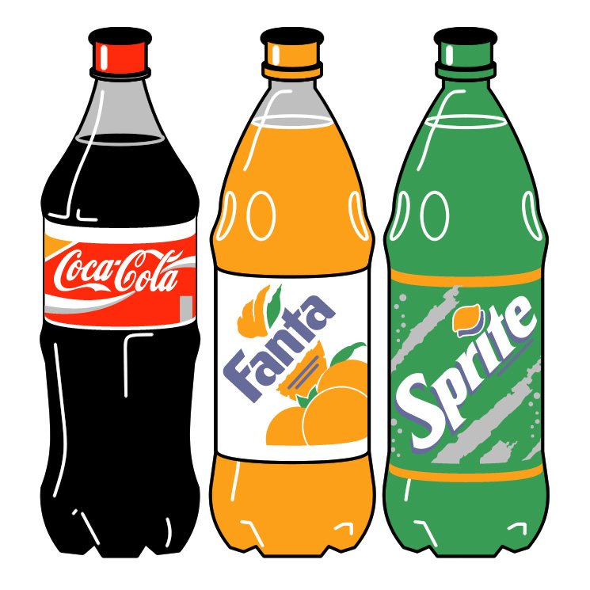 |  | 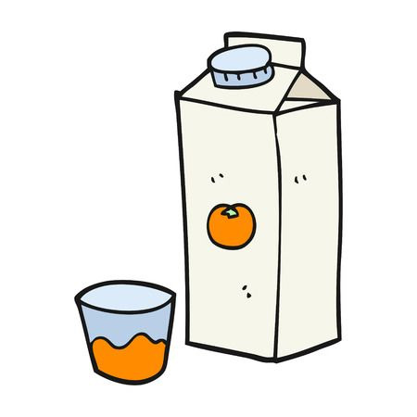
ᎪᎸᏍᏔᏅᎯ |  | ᎠᏓᎶᏂᎨ ᎦᏁᎲ

