**7.2. ᏏᏊ ᏕᎯᎷᎩ!**

**ᎯᎪᎵᏰ ᎪᏪᎳᏅᎯ ᎯᎠ ᎠᏂᏴᏫ. ᎨᏙ ᎢᏳᏍᏗ ᎠᎾᏛᏁᎰᎢ? ᎧᎩ ᎢᏳᏍᏗ ᎯᎠ ᎠᏂᏴᏫ?**

 

ᏤᎻ ᏚᏙᎠ ᎯᎠ ᎠᏍᎦᏯ. ᎠᎿᏪᎩ ᏚᏙᎠ ᎯᎠ ᎠᎨᏯ.

ᏔᎷᏣ ᎠᎳᏍᎦᎳᏗ ᎠᏁᏝᏗᏍᎪᎢ. ᏧᏰᏲᎲᏍᎩ. ᏣᎳᎩ ᏧᎾᏕᎶᏆᏍᏗᏱ

ᎺᎵ ᏚᏙᎠ ᎤᎵᏏ. ᏣᎳᎩᏱ ᏚᏓᎴᏅᎢ ᏚᎸᏫᏍᏓᏁᎰᎢ. Bill ᏚᏙᎠ ᎤᏙᏓ ᏃᎴ

(ᏧᏪᏅᏒ). ᎠᏲᎧ ᏚᏙᎠ ᎤᏥ.

 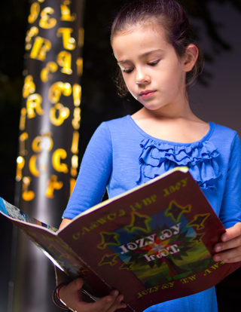

ᏦᎾ ᏚᏙᎠ ᎯᎠ ᎠᏧᏣ. ᏥᏍᏆ ᏚᏙᎠ ᎯᎠ ᎠᎨᏳᏣ.

ᏩᏲᎯ ᏚᏓᎴᏅᎢ (ᏧᏪᏅᏒ). ᏍᏈᏍᏓ ᏗᎪᏪᎵ ᏓᎪᎵᏰᏍᎪᎢ.

ᏌᎳᎵᏏ ᏚᏙᎠ ᎤᏥ. ᎦᎳᏣᏗ ᏚᏙᎠ ᎠᎦᏔᎾ (ᎠᏌᎹᏗ) ᎯᎠ ᎠᎨᏳᏣ!

ᎤᏙᏓ. ᎤᏙᎯᏳ ᎣᏍᏓ ᏗᎿᏬ ᏧᎸᏉᏗ. Marie ᏚᏙᎠ ᎤᏥ ᏃᎴ ᎢᏃᎵ ᏚᏙᎠ ᎤᏙᏓ.

**7.3 ᎠᎦᏎᏍᏙᏗ!**

1. ᎧᎩ ᎢᏳᏍᏗ ᎤᏥ ᏥᏍᏆ? _____________________________
2. ᎨᏙ ᎢᏳᏍᏗ ᎤᎸᏉᏗ ᏦᎾ? _____________________________
3. ᎧᎩ ᎢᏳᏍᏗ ᎠᏁᏝᏗᏍᎪᎢ ᏔᎷᏣ ᎠᎳᏍᎦᎳᏗ? ______________________________
4. ᎦᏨ ᏚᎸᏫᏍᏓᏁᎰᎢ ᎠᎿᏪᎩ? ____________________________
5. ᎧᎩ ᎢᏳᏍᏗ ᏍᏈᏍᏓ ᏗᎪᏪᎵ ᏓᎪᎵᏰᏍᎪᎢ? ___________________________
6. ᎦᏨ ᏧᏪᏅᏒ ᏤᎻ? ____________________________________
7. ᎧᎩ ᎢᏳᏍᏗ ᎤᏥ ᎠᎿᏪᎩ? _______________________________
   1. **ᏂᎯᎾ?**

ᎧᎩ ᎢᏳᏍᏗ ᏂᎯ? 5 ᏗᏒᏍᏙᏗ (sentence) .ᏙᏪᎳᎦ. ᎨᏙ ᎢᏳᏍᏗ ᏕᏣᏙᎠ? ᎧᎩᏳᏍᏗ ᏕᏣᏓᏘᎾᎥᎢ? ᎦᏨ ᏗᏤᏅᏒ (/ ᏕᏣᏓᎴᏁᎢ)? ᏕᏣᎸᏫᏍᏓᏁᎰᎢᏍ? ᎦᏨ? ᎨᏙ ᎢᏳᏍᏗ ᏕᎯᎦᏎᏍᏗᏍᎪᎢ?

**______________________________________________________________________________________**

**______________________________________________________________________________________**

**______________________________________________________________________________________**

**______________________________________________________________________________________**

**______________________________________________________________________________________**

* 1. **.ᏙᏪᎳᎦ! ᎩᎶᎢ ᏄᏓᎴᎢ ᎤᏤᎵ ᎧᏃᎮᏓ .ᏙᏪᎳᎦ.**

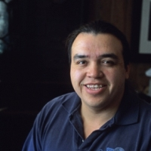

ᎧᎩ ᎢᏳᏍᏗ ᎯᎠ? ᎨᏙ ᎢᏳᏍᏗ ᏚᏙᎠ? ᎦᏨ ᏚᏓᎴᏁᎢ? ᎦᏨ ᏚᎸᏫᏍᏓᏁᎰᎢ? ᎧᎩ ᎢᏳᏍᏗ ᏏᏓᏁᎸ ᎤᏤᎵ? 5 ᏗᏒᏍᏙᏗ .ᏙᏪᎳᎦ! (ᎪᎱᏍᏗ ᎰᏒᎾ*) *make it (up)

**______________________________________________________________________________________**

**______________________________________________________________________________________**

**______________________________________________________________________________________**

**______________________________________________________________________________________**

**______________________________________________________________________________________**

* 1. **ᏔᎵᏁ ᎢᏳᏩᎦᏘ: ᏧᎾᏛᎾᏘ ᏗᎧᏁᎢᏍᏗ**

**7.2** ᎪᏪᎳᏅᎢ ᏗᏒᏍᏙᏗ ᏕᎯᎪᎵᏰ. ᎨᏙ ᎢᏳᏍᏗ ᎠᏍᏆᏂᎪᏙᏗ ᏓᏃᏪᎳᏅ ᎯᎠ ᏗᎧᏁᎢᏍᏗ (A ᎠᎴ B)? ᎨᏙ ᎤᏍᏗ ᏴᏫ ᏓᏃᏪᎳᏅᎢ (1Ᏹ, 2Ꮑ, 3Ꮑ)? ᎲᎦ ᎢᏯᏂ ᎠᏂᏴᏫ (1? 2? ᎠᎴ ᎠᎦᏓ*)? *more?

ᎠᏍᏆᏂᎪᏙᏗ: ᏴᏫ: ᎠᏎᏍᏗ?

1. “ᏚᏙᎠ” A B 1 2 3 1 2 ᎠᎦᏓ
2. “ᎠᏁᏝᏗᏍᎪᎢ” A B 1 2 3 1 2 ᎠᎦᏓ
   1. **ᏧᎾᏛᎾᏘ ᏗᎧᏁᎢᏍᏗ .ᏙᏪᎳᎦ!**

|  |  |  |  |  |  |
| --- | --- | --- | --- | --- | --- |
|  | ᏐᏉ ᏴᏫ | ᏔᎵ ᎠᏂᏴᏫ | | | ᎠᎦᏓ ᏴᏫ |
| 1Ᏹ ᏴᏫ |  | ᏂᎯᏍᏊ (incl.) |  | |  |
| ᎨᏍᏗ ᏂᎯ ᏱᎩ  (excl.) |  | |  |
| 2Ꮑ ᏴᏫ |  |  | | |  |
| 3Ꮑ ᏴᏫ | ᏚᏙᎠ |  | | |  |
|  | ᏐᏉ ᏴᏫ | ᏔᎵ ᎠᏂᏴᏫ | | | ᎠᎦᏓ ᏴᏫ |
| 1Ᏹ ᏴᏫ |  | ᏂᎯᏍᏊ (incl.) | |  |  |
| ᎨᏍᏗ ᏂᎯ ᏱᎩ(excl.) | |  |  |
| 2Ꮑ ᏴᏫ |  |  | | |  |
| 3Ꮑ ᏴᏫ | ᎠᏁᏝᏗᏍᎪᎢ |  | | |  |

* 1. **ᎨᏙ ᎢᏳᏍᏗ ᏧᏂᎸᏉᏗ*?** *they like

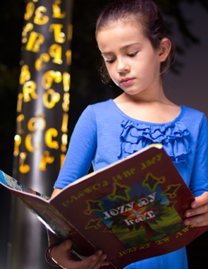 

ᎯᎠ ᏥᏍᏆ. ᏗᎪᏪᎵ ᏧᎸᏉᏗ! ᎯᎠ ᏦᎾ. ᎣᏍᏓ ᏗᎿᏬ ᏧᎸᏉᏗ!

ᏍᏈᏍᏓ ᏓᎪᎵᏰᏍᎪᎢ. ᎤᏬᏚ ᎤᏁᎦ ᎤᎿᏬ .ᎪᎯ ᎢᎦ.

1. ᎨᏙ ᎢᏳᏍᏗ ᏧᎸᏉᏗ ᏥᏍᏆ? ____________________________
2. ᎨᏙ ᎢᏳᏍᏗ ᏧᎸᏉᏗ ᏦᎾ? _______________________________

ᎯᎠ ᎠᏂᏴᏫ ᏍᏈᏍᏓ ᏄᎾᏓᎴᎢ ᏧᏂᎸᏉᏗ! ᏗᏒᏍᏙᏗ .ᏙᏪᎳᎦ!

ᎥᏍᎩ ᎢᏳᏍᏗ: “ᏥᏍᏆ - ᏗᎪᏪᎵ” 🡺 “ᏗᎪᏪᎵ ᏧᎸᏉᏗ ᏥᏍᏆ.”

“ᏦᎾ - ᎣᏍᏓ ᏗᎿᏬ” 🡺 “ᎣᏍᏓ ᏗᎿᏬ ᏧᎸᏉᏗ ᏦᎾ.”

1. ᏤᎻ - ᏔᎷᏣ ᎠᎳᏍᎦᎳᏗ 🡺 ____________________________________________________________
2. ᏫᎵ - ᏣᎳᎩ ᎦᏬᏂᎯᏍᏗ 🡺 ______________________________________________________________
3. ᎺᎵ - ᏣᏔᎦ 🡺 ____________________________________________________________________________
4. ᎠᎿᏪᎩ - ᎤᏕᎶᏆᏍᏗ* 🡺 ____________________________________________________________ *‘for her to learn’
5. ᎠᏲᎧ - ᏒᎦᏔ 🡺 _________________________________________________________________________
6. ᎹᏎ - ᎧᏫ ᎤᏗᏔᏍᏗ* 🡺 _____________________________________________________________ *for her to drink
   1. **ᎤᏛᏁᏘ* ᎤᎸᏉᏗ!** *for him/her to do it

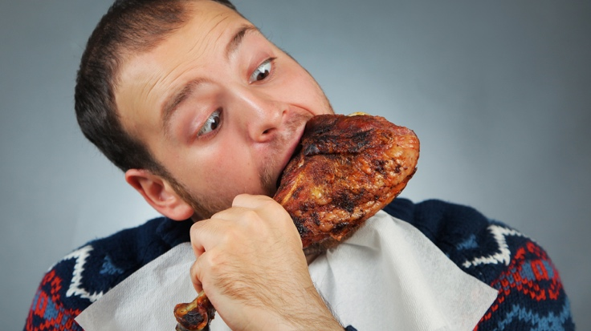 

**ᏣᏔᎦ ᎤᎳᏍᏓᏴᏗ ᎤᎸᏉᏗ ᎯᎠ ᎠᏍᎦᏯ!** ᎤᏬᎩᏟ ᎤᏗᏔᏍᏗ ᎤᎸᏉᏗ ᎯᎠ ᎠᏍᎦᏯ*

.ᏙᏪᎳᎦ!

ᎨᏙ ᎢᏳᏍᏗ ᎤᎾᏛᏁᏘ ᏧᏂᎸᏉᏗ ᎯᎠ ᎠᏂᏴᏫ?

ᎯᎠ ᎢᏳᏍᏗ: “Bobby - ᏣᏔᎦ* ᎤᎵᏍᏓᏴᏗ”🡺 “ᏣᏔᎦ ᎤᎵᏍᏓᏴᏗ ᎤᎸᏉᏗ Bobby.” *chicken

1. ᏛᎩ - ᏗᎪᏪᎵ ᎤᎪᎵᏰᏗ 🡺 _______________________________________________________________
2. ᏎᎾ - ᏍᏓᏯ ᏚᎸᏫᏍᏓᏁᏗ 🡺 _____________________________________________________________
3. ᎤᎾᏚᏘ - rugby ᎤᏁᏝᏙᏗ 🡺 _____________________________________________________________
4. ᏚᏯ - ᎦᏬᏂᎯᏍᏗ ᎤᏕᎶᏆᏍᏗ 🡺 _____________________________________________________________
5. ᎧᏬᏄ - ᎤᏓᏬᏍᏗ 🡺 _____________________________________________________________

**7.9.1.** ᎢᏳᎾᏛᏁᏗ: “Infinitives”

Constructions like “ᏣᏔᎦ ᎤᎵᏍᏓᏴᏗ ᎤᎸᏉᏗ ᏣᏂ” include an *infinitive*. Infinitives in Cherokee are formed using the *deverbal noun stem*. Recall that there are 5 stems for each Cherokee verb – the deverbal noun stem is the 5th. Infinitives can be used when you want to make a verb the **direct object** of another verb. Ordinarily, the **direct object** is a noun – the thing that receives the action of the verb.

Ex.

I want **an apple**

**Subject Verb direct object (“an apple” is the thing that gets “wanted.”)**

You can put a verb in this position instead. In English, we do this using the word “to.”

I want to eat

**Subject Verb direct object** (here, “to eat” is what is “wanted.”)

In Cherokee, the deverbal noun stem is the equivalent of the English “to.” Because it still carries a prefix though, it can be translated as “for (me/you/him, etc.) to do it”

ᎤᎵᏍᏓᏴᏗ ᎤᏚᎵᎭ ᏣᏂ

“for him to eat” “he wants it” John

ᏚᎸᏫᏍᏓᏁᏗ ᎤᎸᏉᏗ ᏫᎵ

“for him to work” “he likes it” Will

As an example of a full stem table, here are the forms of the verb “help” (root= -asdeliha):

1. Present Continuous *a-sdeliha* “(s)he is helping”
2. Incompletive *a-sdelisg-v’i*  “(s)he was helping”
3. Immediate *a-sdela* “(s)he helped (just now)”
4. Completive *u-sdelvh-v’i* “(s)he helped”
5. Deverbal Noun *u-sdehld-i* “for him/her to help”

Each stem denotes a different *tense* (time in which the event happened), and *aspect* (whether or not the event is identified as *complete* or *incomplete*). Note that in stems 1-3, the verb “help” takes the Set A prefixes, but switches to Set B in 4 & 5. This is true for all Set A verbs.

**Exercise!**

Given the *deverbal noun stem* for each verb, write a sentence using either “likes to” (-ᎸᏉᏗ) or “wants to” (-ᎠᏚᎵᎭ). Use the prefix appropriate to the person indicated.

Ex. -ᏍᏕᎳᏗ “help” – 1st person singular - ᎠᏆᏍᏕᎳᏗ ᎠᏆᏚᎵᎭ!

(NOTE: Your prefixes on both verbs should match! It changes the meaning if they don’t.)

1. -ᎠᏗᏔᏍᏗ “drink” – 1st person dual exclusive - ___________________________________________
2. -ᎸᏫᏍᏓᏁᏗ “work” – 3rd person plural - ______________________________________________________
3. -ᏃᎩᏍᏗ “sing” – 2nd person singular - ________________________________________________________
4. -ᎪᎵᏰᏗ “read” – 2nd person dual - _____________________________________________________________
5. -ᎣᏪᎶᏙᏗ “write” – 1st person dual inclusive - _______________________________________________
6. -ᎠᎵᏍᎩᏍᏗ “dance” – 1st person plural inclusive - __________________________________________
7. -ᎠᏕᎳᎰᎯᏍᏗ “find out” – 3rd person plural - _________________________________________________
8. -ᏬᏂᏍᏗ “speak” – 1st person singular - _______________________________________________________
9. -ᎠᏕᎶᏆᏍᏗ “learn” – 2nd person plural - ______________________________________________________
10. -ᎠᏓᎾᏖᏗ “think” – 1st person singular - _______________________________________________________
    1. **Facing East! Lifestyle & Custom**

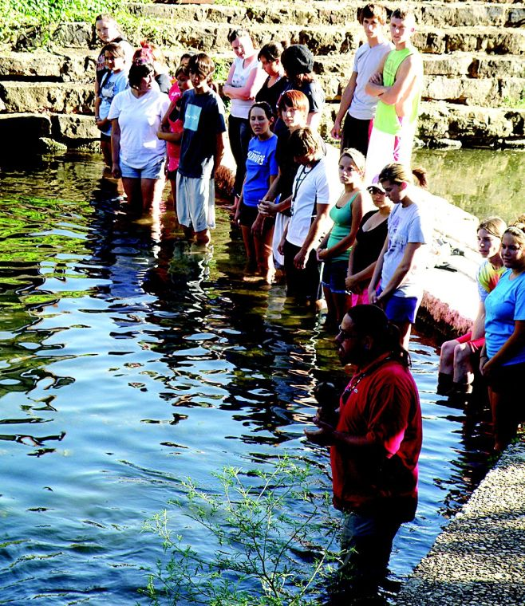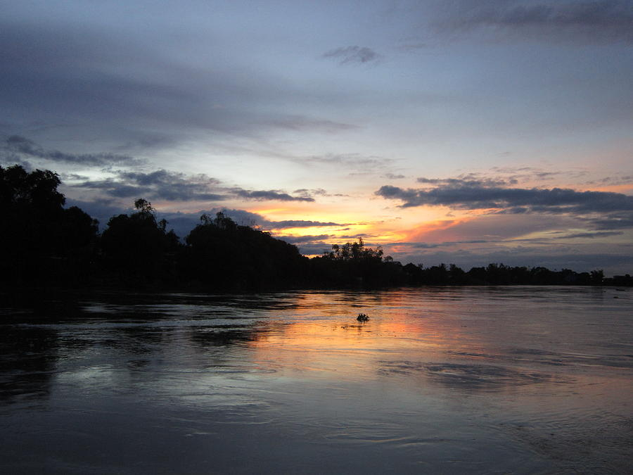

When going to water, Cherokees face east – the direction of the rising sun. The sun, and by extension the east, are symbols of renewed hope, warmth, and life. The sun represents the Creator, ᎤᏁᏝᏅᎯ. Beyond mere symbolism, we recognize that the sun is the source of all energy on Earth, and consequently, all life. Just as the sun represents the Creator in the sky, the fire represents ᎤᏁᏝᏅᎯ on Earth. The sun warms and enlivens the Earth while the fire provides people with warmth, protects them from predators, cooks their food, and brings them together into companionable circles.

In a very real sense, fire pulls people together. It is this basic acknowledgement – that the sun and the fire are responsible for the continuity of our bodies, our sustenance, and our well-being within communities – that gives rise to a daily sense of gratitude. This is why going to water and attending dances has historically been important. It puts people in touch with fundamental facts about where their roots are – in the earth and the life it provides, and in the fire.