**5.4 ᎨᏙ ᎢᏳᏍᏗ ᏧᏂᎾᏩ?**

ᎠᎿᏬ ᎠᏌᏃ ᎠᏑᎶ ᎤᏍᏆᎳ ᏗᎦᎳᏯᏗ ᎠᏑᎶ

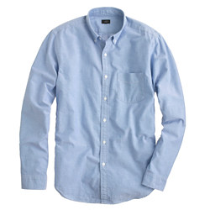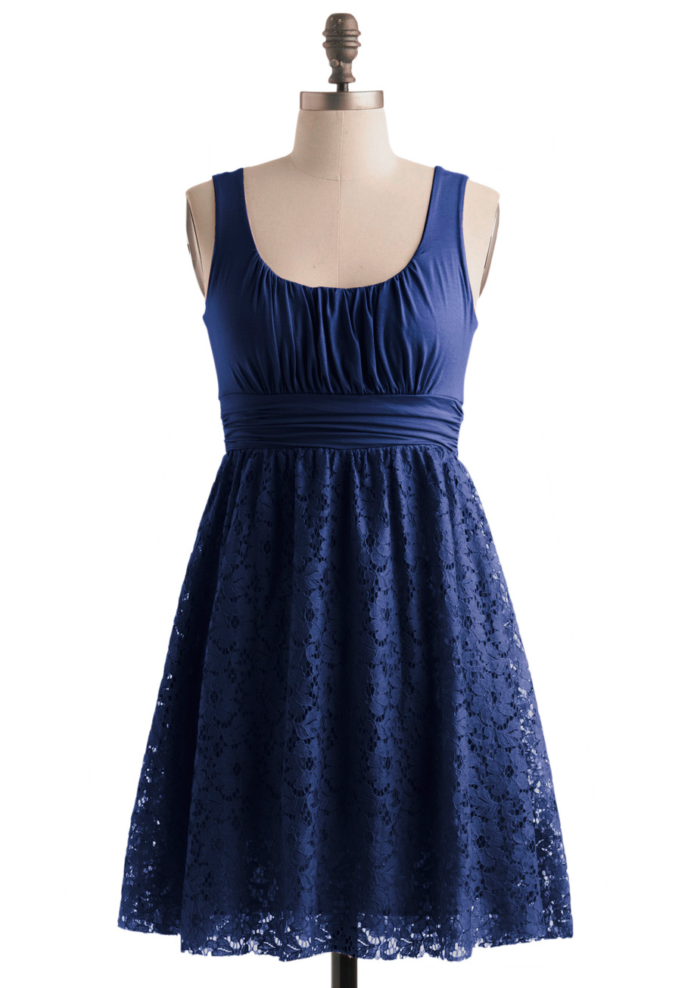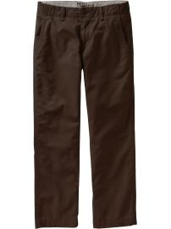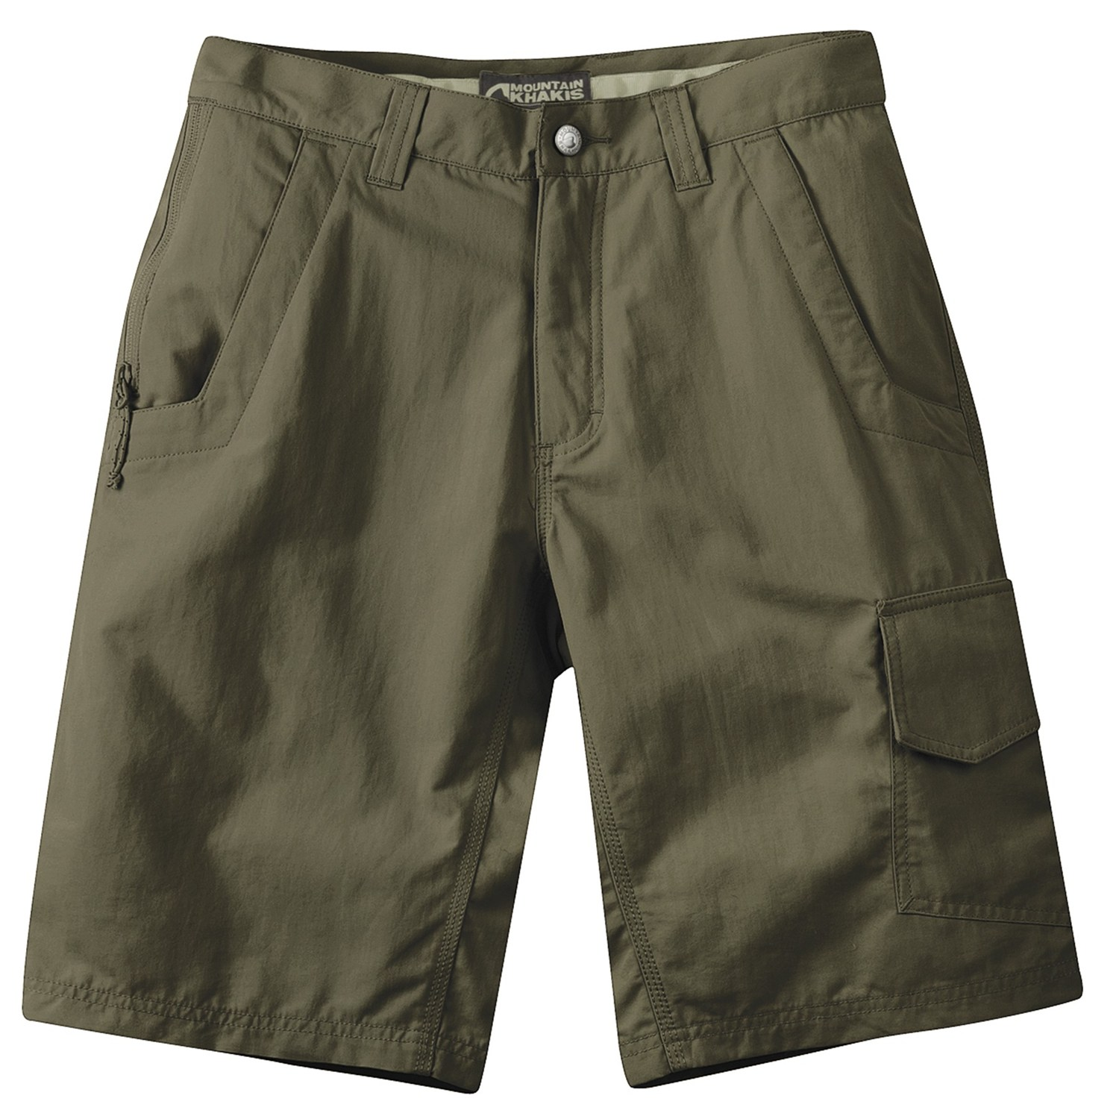

ᎠᎵᏲ ᎠᎳᏑᎶ ᏗᎦᏘᏅᏓ ᎭᏫᎾ ᎠᏑᎶ

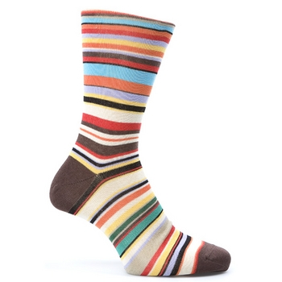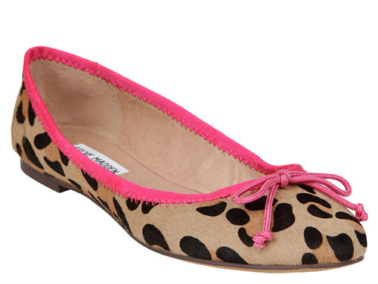

ᎦᏌᎴᎾ ᎤᏌᎨᏓ ᎦᏌᎴᎾ ᎠᏍᏚᎶ

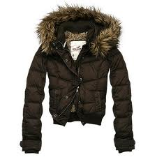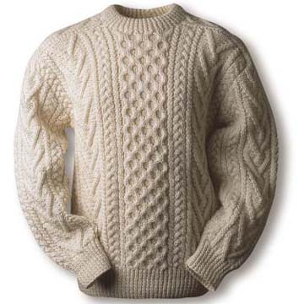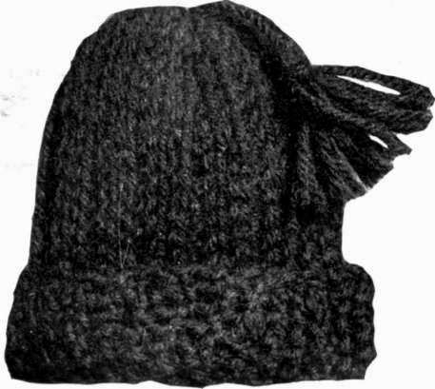

ᎠᎵᏍᏇᏔᏬ ᏩᏥ ᎠᏴᏨᏗ

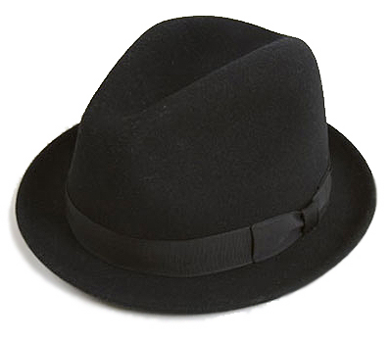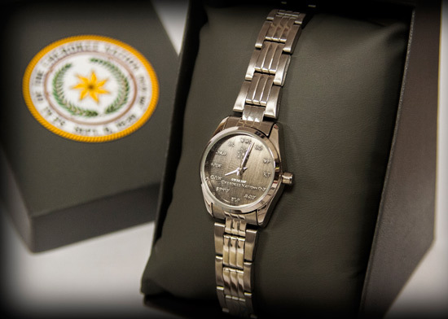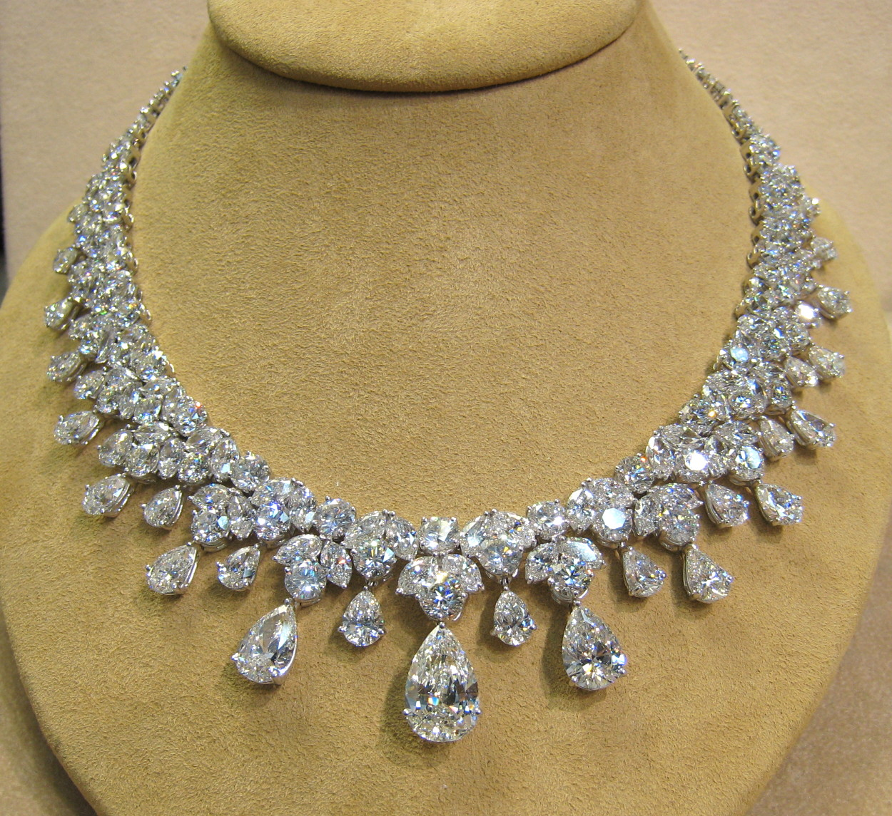

ᎤᎳᏍᎨᏗ ᏗᎿᏬᏍᏗ ᎤᎳᏍᎨᏗ ᎠᏌᏃ ᎠᎧᏁᏍᏗ ᎠᏴᏨᏓ

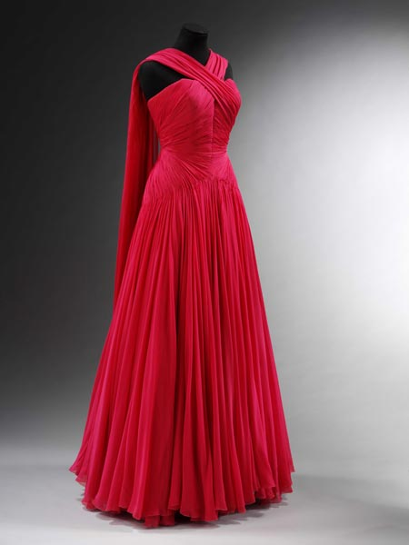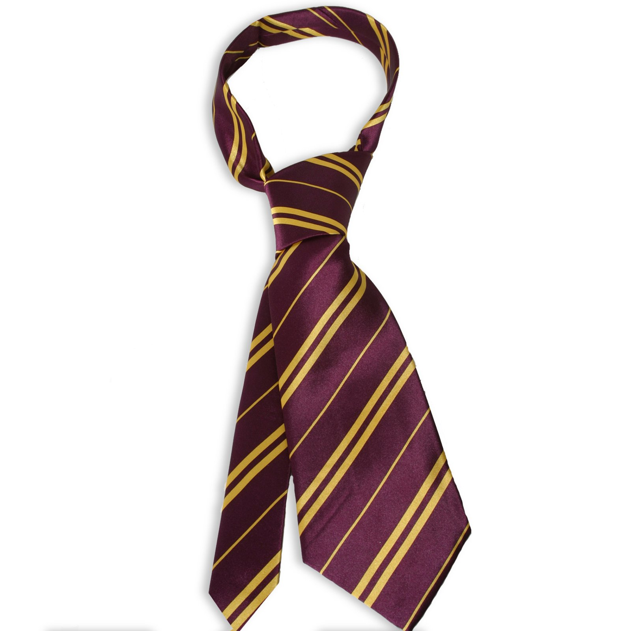

ᎠᎵᏰᏑᎳ ᏗᎦᎴᏂ ᏗᎦᏛᏗ ᎠᏓᏦᏍᏗ

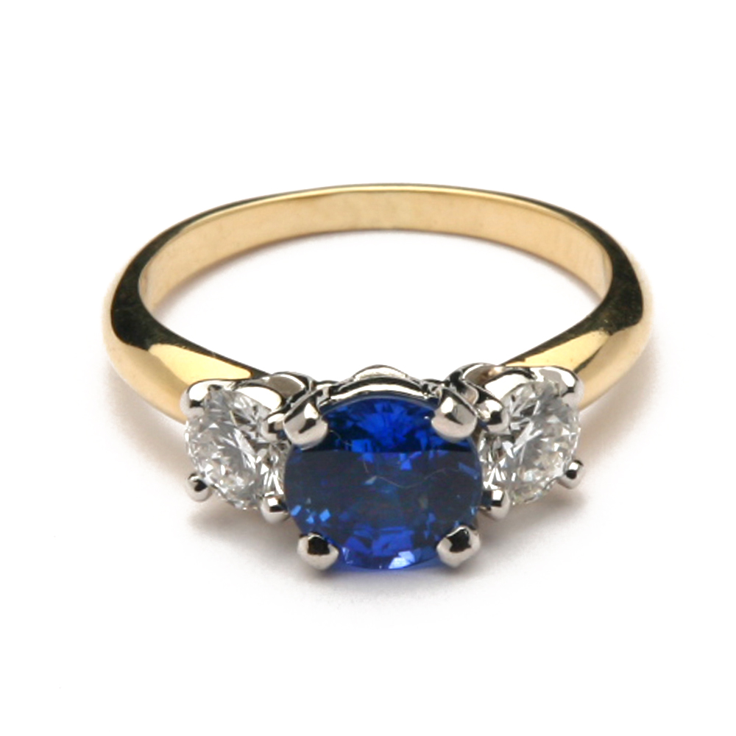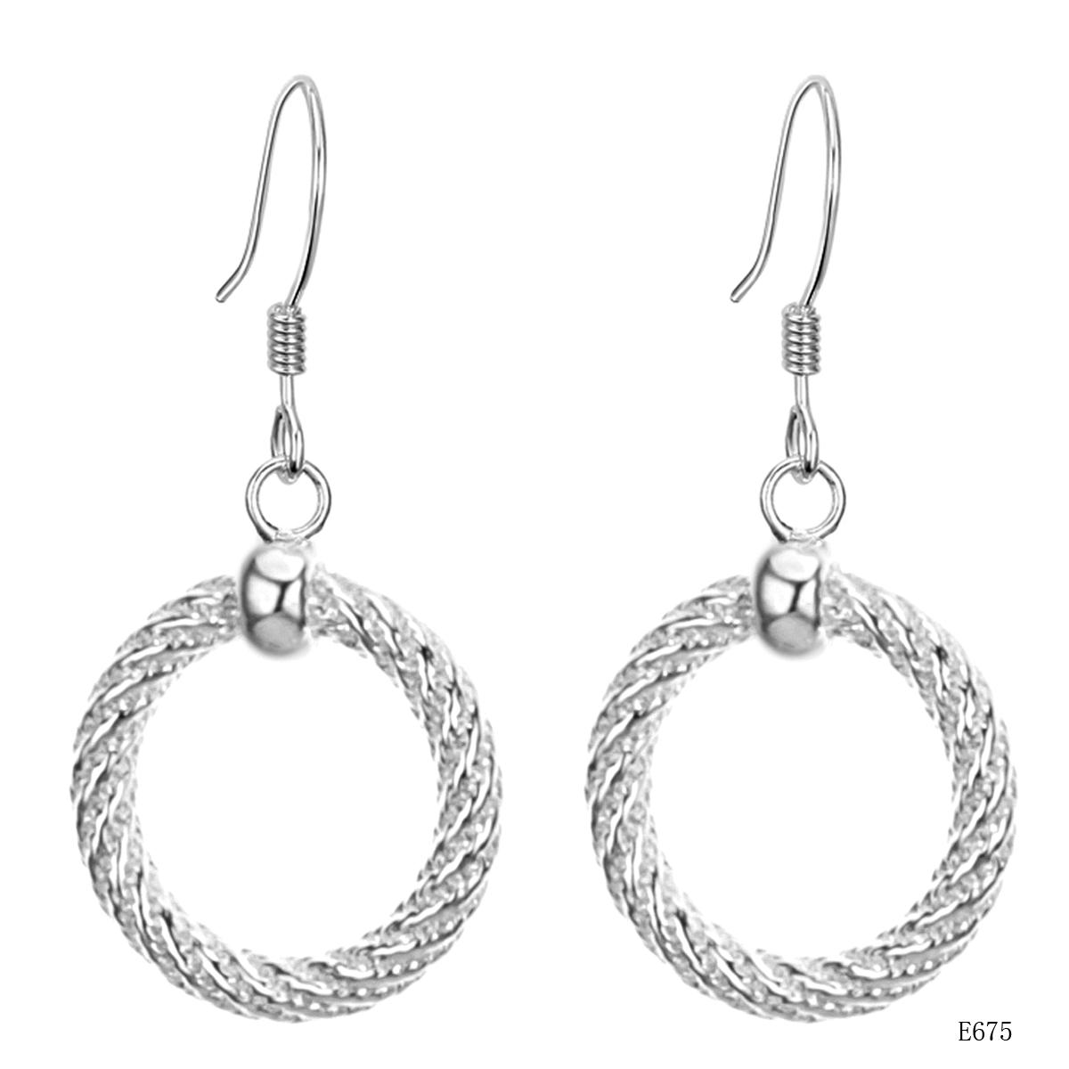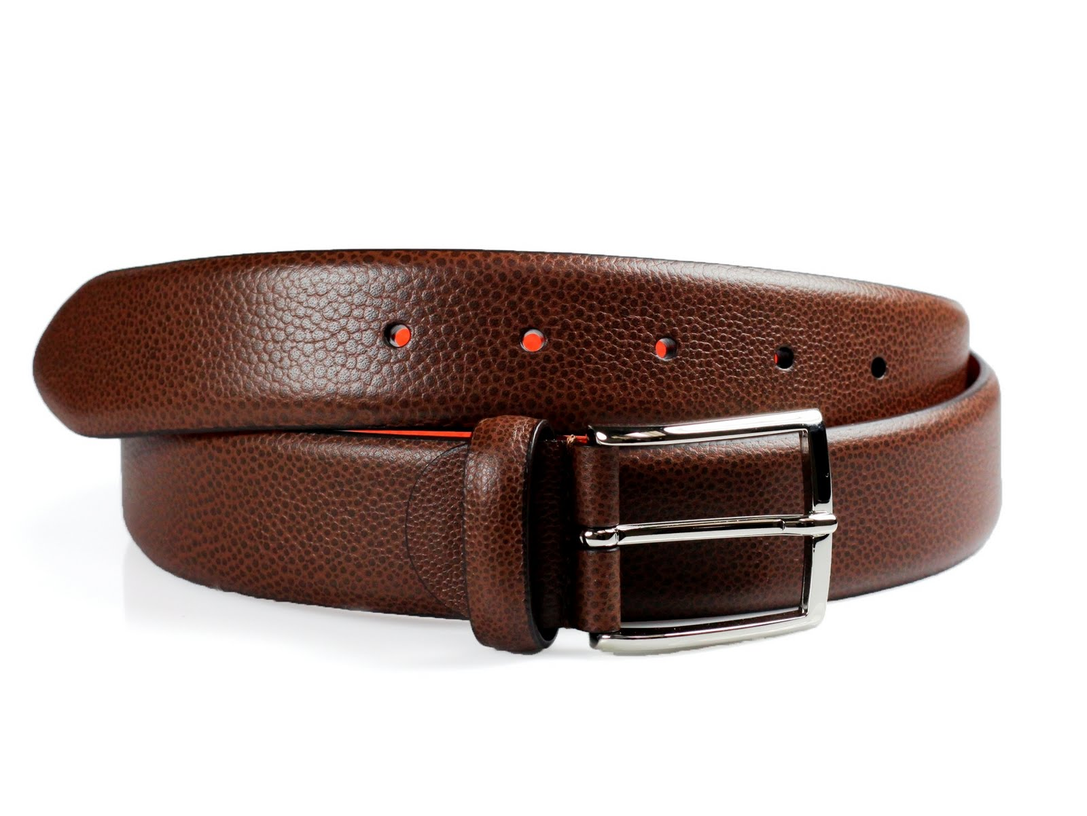

ᏗᎧᏁᏍᏗ* lit. ‘connectors’ ᏗᎵᏰᏑᎶ ᏗᎧᏁᏍᏗ

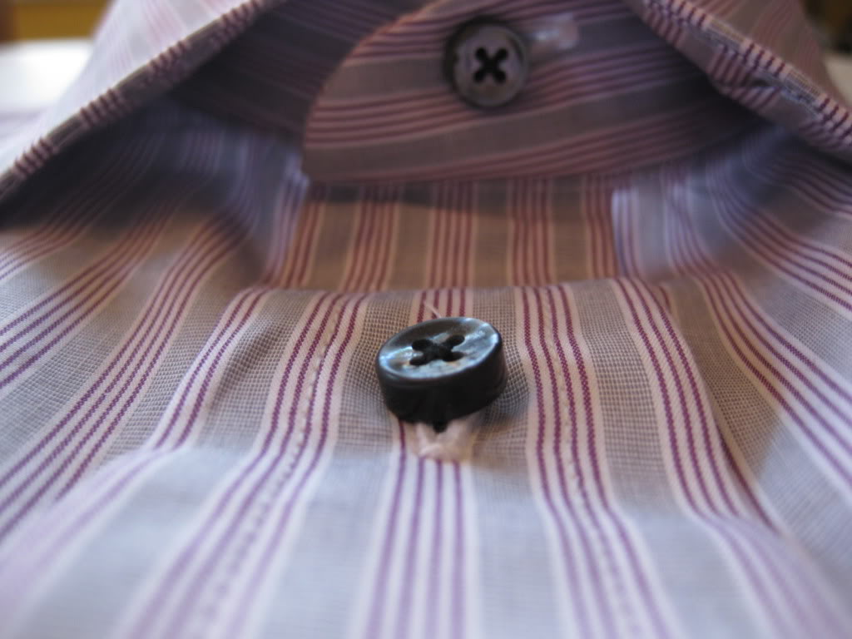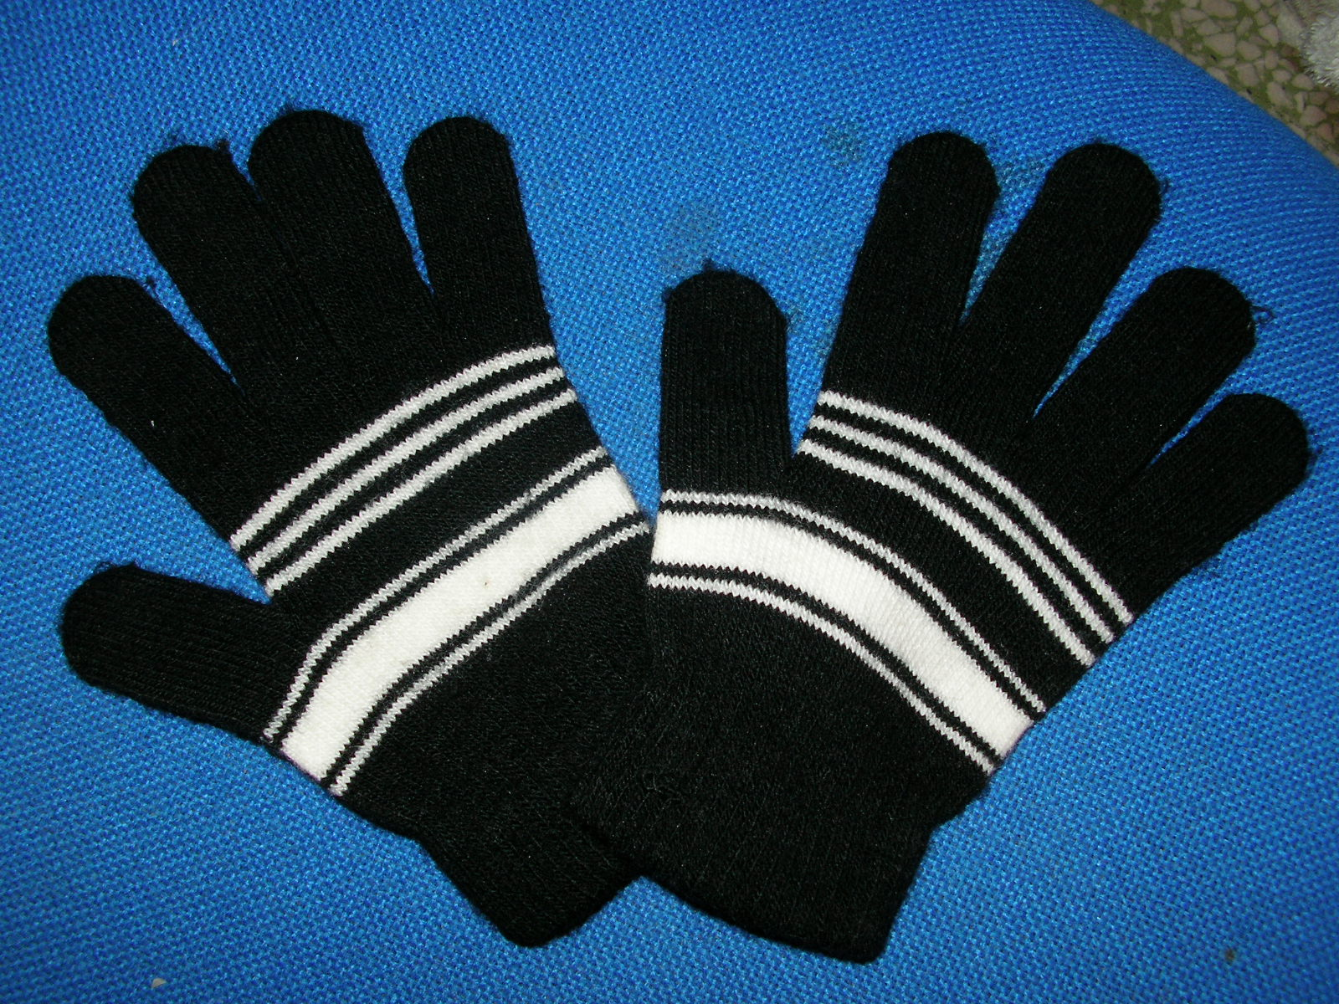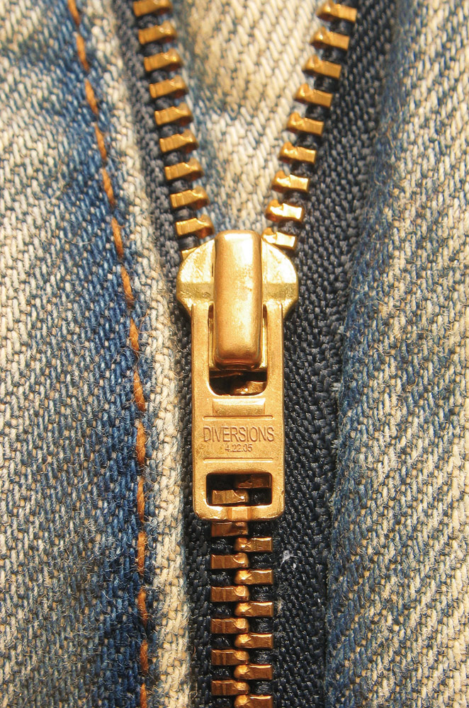

**5.5 .ᎨᏙ ᎢᏳᏍᏗ ᎤᏩᎯᏍᏗ* ᎤᏚᎵᎭ? *to buy**

ᏗᏤᎢ** ᏧᎾᏬ ᎤᏩᎯᏍᏗ ᎤᏚᎵᎭ ᎢᏃᎵ. ᎯᏍᏕᎳ** ᎤᏑᏰᏍᏗ***! **\*new **help ***to choose**

1. **ᎩᎦᎨᎢ ᎦᏌᎴᎾ ᎤᏩᎯᏍᏗ ᎤᏚᎵᎭ! ᎨᏙ ᎢᏳᏍᏗ ᎤᏩᎯᏍᏗ? __________**
   1.  **C.** 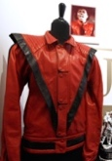
   2.  **D.** 
2. **ᎬᏂᎨᎢ ᎠᎵᏍᏇᏔᏬ ᎤᏩᎯᏍᏗ ᎤᏚᎵᎭ. __________**

* 1.  **C.** 
  2. 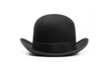 **D.** 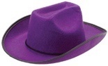

1. **Ꮜ.ᎪᏂᎨᎢ ᎠᎧᏁᏍᏗ ᎠᏴᏨᏓ ᎤᏩᎯᏍᏗ ᎤᏚᎵᎭ. __________**
   1.  **C.** 
   2.  **D.** 
2. **ᎤᏬᏗᎨᎢ ᎠᏓᏦᏍᏗ ᎤᏚᎵᎭ. __________**
   1.  **C.** 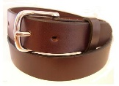
   2.  **D.** 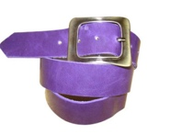

**5.6 Lifestyle & Custom**

One thing that has remained constant in Cherokee culture is a propensity toward adaptation. As the old adage goes, “the only thing that does not change is change itself.” In order to survive, Cherokees have had to continually adapt to new developments in the world around them. This has meant new ways of thinking about culture, politics, religion, and even style. As people came in contact with foreign ideas, they began adopting them, and putting their own Cherokee spin on them. This can be seen in the fashions of earlier chiefs like Oconostota (ᎣᎦᎾ ᎠᏍᏙᏓ - pounded groundhog) and Ostenaco (born 1704, 1703 respectively):

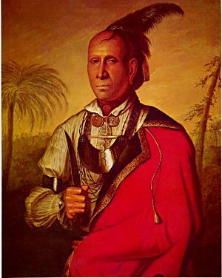 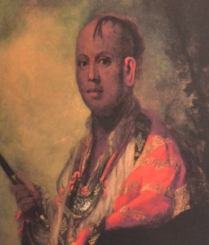

And later in the likes of Dragging Canoe (ᏥᏳ ᎦᏅᏏᏂ - born ca.1738) and John Ross (born 1790):

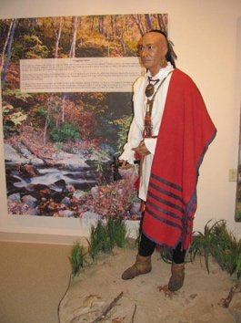 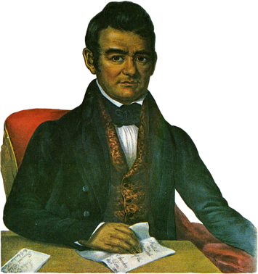

Today’s Cherokee Chiefs feel free to integrate contemporary American and Cherokee fashions, much as their predecessors did:

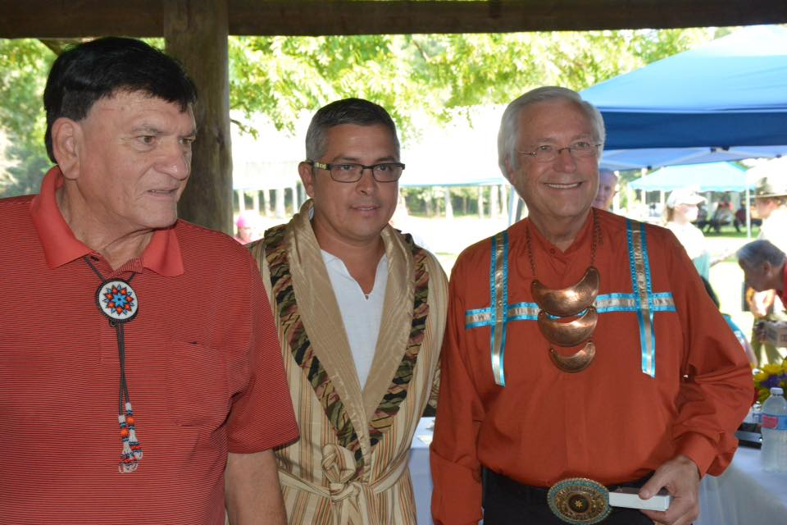

Pictured left to right: Chief George Wickliffe, United Keetoowah Band of Cherokee Indians; Chief Michelle Hicks, Eastern Band of Cherokee Indians; Chief Bill John Baker, Cherokee Nation. Taken at joint council meeting, Red Clay, TN, 2015.