**Ch. 05 Stylin’!**

Inoli and Tsunulahvsgi meet up at the Occonaluftee Island Park. Tsunulahvsgi has recently been shopping, and is strutting around in all manner of new swag.

ᎢᏃᎵ: ᏏᏲ ᏄᎳᎲᏍᎩ! .ᏙᎯ?

ᏧᏄᎳᎲᏍᎩ: ᎥᎥ, ᏙᎯᏊ. ᎢᎯᎾ?

ᎢᏃᎵ: ᎣᏏᏊ. Ꭾ! ᎣᏍᏓ ᎠᎩᏰᎸᎢ ᎿᏬᎠ! ᎤᏚᎯ Ꮎ Ꮜ.ᎪᏂᎨᎢ ᎠᏑᏍᏗ.

ᏧᏄᎳᎲᏍᎩ: ᏍᎩ! Belk Ꭰ.ᎩᎯᏍᎬᎢ. ᎩᎦᎨᎢ ᎠᏆᏚᎵᏍᎬᎢ, ᎠᏎᏍᎩᏂ ᎣᏏᏊᏛ Ꮎ Ꮜ.ᎪᏂᎨ.

ᎢᏃᎵ: ᎧᏂᎩᏓᏍ ᎩᎦᎨᎢ ᏧᏂᎾᎥᎢ?

ᏧᏄᎳᎲᏍᎩ: ᎭᏗ.

ᎢᏃᎵ: hm. Ꮟ ᎠᎩᎸᏉᏗ! ᏗᎢᏍᏊ ᏗᎳᏑᎶ?

ᏧᏄᎳᎲᏍᎩ: ᎥᎥ! ᎦᏄᎳ ᎾᏆᎵᏍᏗᎮᏍᏗ ᏃᏊ!

ᎢᏃᎵ: ᎥᎥ! ᎭᎭᎭ… ᎠᏉᎯᏛ!

ᏧᏄᎳᎲᏍᎩ: ᏕᎾᏓᎪᎲ ᎢᏃᎵ!

ᎢᏃᎵ: Ꭽ!

**Terms**:

ᎣᏍᏓ ᎠᎩᏰᎸᎢ ‘I like (it)’ (lit. ‘I feel good [about]…) -ᏍᏊ also/too

ᎠᎩᎸᏉᏗ ‘I like (it)’ ᎢᎯᎾ variant of ᏂᎯᎾ?

ᎿᏬᎠ your shirt ᏗᎳᏑᎶ your shoes

ᎤᏚᎯ pretty/beautiful ᎦᏄᎳ fast/quick

Ꮎ that _______ ᎾᏆᎵᏍᏗᎮᏍᏗ I will become

Ꮜ.ᎪᏂᎨᎢ blue ᎢᎢ new

ᎩᎦᎨᎢ red ᏃᏊ now

ᎠᏑᏍᏗ color ᎤᏁᎩᏟᏗ ugly

Ꭰ.ᎩᎯᏍᎬᎢ ‘I bought (it)’ ᎤᏍᏆᏂᎦᏘ interesting/

ᎠᏆᏚᎵᏍᎬᎢ ‘I wanted (it)’ fancy

ᎠᏎᏍᎩᏂ but/however

ᎧᏂᎩᏓ none

ᏧᏂᎾᎥᎢ they had (them) – flexible object

Ꮟ still

Ꮧ- plural marker (non-verbs)

**5.1 ᎭᎳᏏᏅᎭ!**

**ᎯᏅᎾ *ᎣᎯᏍᏗᏳ***\* **ᎦᏬᎯᎵᏴᏓ** \***best **answer

1. ᎨᏙ ᎢᏳᏍᏗ ᎤᏩᏍᎨᎢ ᏧᏄᎳᎲᏍᎩ? _____________
   1. ᏕᎦᏝᏗᎢ C. ᏓᏆᎴᎳ
   2. ᎠᎿᏬ D. ᏐᏈᎵ
2. ᎦᏨ ᎠᏓᎾᏁᏏᏙᎮᎢ ᏧᏄᎳᎲᏍᎩ? _____________
   1. Belk C. Sak’s Fifth Avenue
   2. J.C. Penny D. ᎤᎵᏏ ᏧᎾᎵᏍᏓᏴᏗᏱ
3. ᎨᏙ ᎢᏳᏍᏗ ᎠᏑᏫᏓ ᎢᏥᎢ ᎤᎿᏬ ᏧᏄᎳᎲᏍᎩ? _____________
   1. ᎩᎦᎨᎢ C. ᎬᏂᎨᎢ
   2. ᏕᎷᎨᎢ D. Ꮜ.ᎪᏂᎨᎢ
4. ᎣᏍᏓᏧ ᎤᏰᎸᎢ ᎢᏤᎢ ᎤᎿᏬ ᏧᏄᎳᎲᏍᎩ? _____________
   1. ᎥᎥ! ᎤᎸᏉᏗᏳ! C. ᎥᎥ…ᎣᏏᏊᏛ.
   2. ᎭᏗ D. ᎧᎩ ᎢᏳᏍᏗ ᏣᏙᏓ?
5. ᎨᏙ ᎢᏳᏍᏗ ᏄᎵᏍᏓᏯᎮᏍᏗ ᏧᏄᎳᎲᏍᎩ ᏃᏊ? _____________
   1. ᎤᏍᎦᏃᎵᎨᎢ C. ᎦᎵᏦᎯᏓ
   2. ᎦᏣᏄᎳᎨᎢ D. ᎠᎵᎮᎵᎦ
6. ᎨᏙ ᎤᏰᏟᏛ ᎦᏣᏄᎵᎨᎢ ᏄᎵᏍᏓᏯᎮᏍᏗ ᏧᏄᎳᎲᏍᎩ? _____________
   1. ᏗᏤᎢ ᏗᎳᏑᎶ ᏧᏩᏍᎬᎢ C. ᎠᎾᎦᎵᏍᎩ ᎤᏅᏥᏓ ᏂᎦᎥ ᎠᎦᏎᏍᏓᏅ ᎠᎦᏎᏍᏗᎭ
   2. ᎤᏔᏅ ᏂᎦᎵᏍᏗᏯᎲᎢ D. ᎤᎬᏫᏳᎯ* ᎤᏙᏓ *chief
7. ᎨᏙ ᎢᏳᏍᏗ ᎠᏑᏫᏓ ᎠᎿᏬ ᎤᏚᎵᏍᎨᎢ ᏧᏄᎳᎲᏍᎩ? _____________
   1. Ꮜ.ᎪᏂᎨᎢ C. ᎠᏓᎶᏂᎨᎢ
   2. ᏕᎷᎨᎢ D. ᎩᎦᎨᎢ

**5.2 ᏗᏑᏫᏍᏗ!**

**ᎩᎦᎨᎢ ᎠᏓᎶᏂᎨᎢ ᏓᎶᏂᎨᎢ ᎠᏤᎢ**

   

**Ꮜ.ᎪᏂᎨᎢ** ᏕᎷᎨᎢ ᎤᏬᏗᎨᎢ ᎤᎾᏉᎳᏛ

   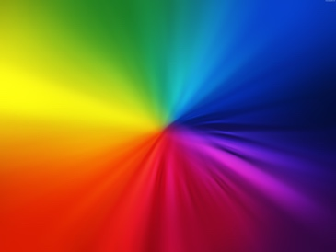

ᎬᏂᎨᎢ ᎤᏁᎦ ᎩᎦᎨᎢ ᎤᏍᎪᎸᎢ ᎬᏂᎨ ᎤᏍᎪᎸᎢ

   

**5.3.** **ᎨᏙ ᎢᏳᏍᏗ ᎠᏑᏫᏓ**?

1. 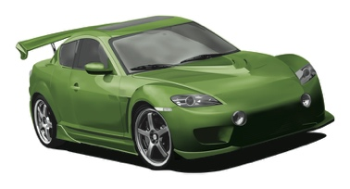_________________ ᏓᏆᎴᎳ
2. 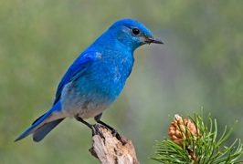 _________________ ᏥᏍᏆ
3. 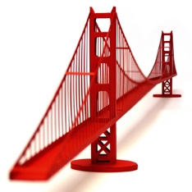 _________________ ᎠᏒᏍᏗ
4. 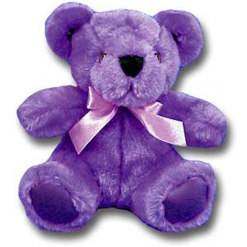 _________________ ᏲᎾ ᎢᏳᏍᏗ ᏗᏁᏟᏙᏗ
5.  _________________ ᎤᎶᎩᎳ
6. 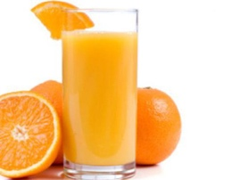 _________________ ᎠᏗᏔᏍᏗ