Ch. 05 Stylin’!
Inoli and Tsunulahvsgi meet up at the Occonaluftee Island Park. Tsunulahvsgi has recently been shopping, and is strutting around in all manner of new swag.

ᎢᏃᎵ: ᏏᏲ ᏧᏄᎳᎲᏍᎩ! .ᏙᎯ?
ᏧᏄᎳᎲᏍᎩ: ᎥᎥ, ᏙᎯᏊ. ᎢᎯᎾ?
ᎢᏃᎵ: ᎣᏏᏊ. Ꭾ! ᎣᏍᏓ ᎠᎩᏰᎸᎢ ᏣᎿᏬᎠ! ᎤᏚᎯ Ꮎ Ꮜ.ᎪᏂᎨᎢ ᎠᏑᏍᏗ.
ᏧᏄᎳᎲᏍᎩ: ᏍᎩ! Belk Ꭰ.ᎩᎯᏍᎬᎢ. ᎩᎦᎨᎢ ᎠᏆᏚᎵᏍᎬᎢ, ᎠᏎᏍᎩᏂ ᎣᏏᏊᏛ Ꮎ Ꮜ.ᎪᏂᎨ.
ᎢᏃᎵ: ᎧᏂᎩᏓᏍ ᎩᎦᎨᎢ ᏧᏂᎾᎥᎢ?
ᏧᏄᎳᎲᏍᎩ: ᎭᏗ.
ᎢᏃᎵ: hm. Ꮟ ᎠᎩᎸᏉᏗ! ᏗᎢᏍᏊ ᏗᎳᏑᎶ?
ᏧᏄᎳᎲᏍᎩ: ᎥᎥ! ᎦᏄᎳ ᎾᏆᎵᏍᏗᎮᏍᏗ ᏃᏊ!
ᎢᏃᎵ: ᎥᎥ! ᎭᎭᎭ… ᎠᏉᎯᏛ!
ᏧᏄᎳᎲᏍᎩ: ᏕᎾᏓᎪᎲ ᎢᏃᎵ!
ᎢᏃᎵ: ᎭᏩ!

Terms:
ᎣᏍᏓ ᎠᎩᏰᎸᎢ ‘I like (it)’ (lit. ‘I feel good [about]…) -ᏍᏊ also/too
ᎠᎩᎸᏉᏗ ‘I like (it)’ ᎢᎯᎾ variant of ᏂᎯᎾ?
ᏣᎿᏬᎠ your shirt ᏗᎳᏑᎶ your shoes
ᎤᏚᎯ pretty/beautiful ᎦᏄᎳ fast/quick
Ꮎ that _______ ᎾᏆᎵᏍᏗᎮᏍᏗ I will become
Ꮜ.ᎪᏂᎨᎢ blue ᎢᎢ new
ᎩᎦᎨᎢ red ᏃᏊ now
ᎠᏑᏍᏗ color ᎤᏁᎩᏟᏗ ugly
Ꭰ.ᎩᎯᏍᎬᎢ ‘I bought (it)’ ᎤᏍᏆᏂᎦᏘ interesting/
ᎠᏆᏚᎵᏍᎬᎢ ‘I wanted (it)’ fancy
ᎠᏎᏍᎩᏂ but/however
ᎧᏂᎩᏓ none
ᏧᏂᎾᎥᎢ they had (them) – flexible object
Ꮟ still
Ꮧ- plural marker (non-verbs)

5.1 ᎭᎳᏏᏅᎭ!
ᎯᏅᎾ ᎣᎯᏍᏗᏳ* ᎦᏬᎯᎵᏴᏓ** ^{*best} ^{**answer}

- ᎨᏙ ᎢᏳᏍᏗ ᎤᏩᏍᎨᎢ ᏧᏄᎳᎲᏍᎩ? _____________
  - ᏕᎦᏝᏗᎢ C. ᏓᏆᎴᎳ
  - ᎠᎿᏬ D. ᏐᏈᎵ

- ᎦᏨ ᎠᏓᎾᏁᏏᏙᎮᎢ ᏧᏄᎳᎲᏍᎩ? _____________
  - Belk C. Sak’s Fifth Avenue
  - J.C. Penny D. ᎤᎵᏏ ᏧᎾᎵᏍᏓᏴᏗᏱ

- ᎨᏙ ᎢᏳᏍᏗ ᎠᏑᏫᏓ ᎢᏥᎢ ᎤᎿᏬ ᏧᏄᎳᎲᏍᎩ? _____________
  - ᎩᎦᎨᎢ C. ᎬᏂᎨᎢ
  - ᏕᎷᎨᎢ D. Ꮜ.ᎪᏂᎨᎢ

- ᎣᏍᏓᏧ ᎤᏰᎸᎢ ᎢᏤᎢ ᎤᎿᏬ ᏧᏄᎳᎲᏍᎩ? _____________
  - ᎥᎥ! ᎤᎸᏉᏗᏳ! C. ᎥᎥ…ᎣᏏᏊᏛ.
  - ᎭᏗ D. ᎧᎩ ᎢᏳᏍᏗ ᏣᏙᏓ?

- ᎨᏙ ᎢᏳᏍᏗ ᏄᎵᏍᏓᏯᎮᏍᏗ ᏧᏄᎳᎲᏍᎩ ᏃᏊ? _____________
  - ᎤᏍᎦᏃᎵᎨᎢ C. ᎦᎵᏦᎯᏓ
  - ᎦᏣᏄᎳᎨᎢ D. ᎠᎵᎮᎵᎦ

- ᎨᏙ ᎤᏰᏟᏛ ᎦᏣᏄᎵᎨᎢ ᏄᎵᏍᏓᏯᎮᏍᏗ ᏧᏄᎳᎲᏍᎩ? _____________
  - ᏗᏤᎢ ᏗᎳᏑᎶ ᏧᏩᏍᎬᎢ C. ᎠᎾᎦᎵᏍᎩ ᎤᏅᏥᏓ ᏂᎦᎥ ᎠᎦᏎᏍᏓᏅ ᎠᎦᏎᏍᏗᎭ
  - ᎤᏔᏅ ᏂᎦᎵᏍᏗᏯᎲᎢ D. ᎤᎬᏫᏳᎯ* ᎤᏙᏓ ^{*chief}

- ᎨᏙ ᎢᏳᏍᏗ ᎠᏑᏫᏓ ᎠᎿᏬ ᎤᏚᎵᏍᎨᎢ ᏧᏄᎳᎲᏍᎩ? _____________
  - Ꮜ.ᎪᏂᎨᎢ C. ᎠᏓᎶᏂᎨᎢ
  - ᏕᎷᎨᎢ D. ᎩᎦᎨᎢ

5.2 ᏗᏑᏫᏍᏗ!

ᎩᎦᎨᎢ ᎠᏓᎶᏂᎨᎢ ᏓᎶᏂᎨᎢ ᎠᏤᎢ


Ꮜ.ᎪᏂᎨᎢ ᏕᎷᎨᎢ ᎤᏬᏗᎨᎢ ᎤᎾᏉᎳᏛ


ᎬᏂᎨᎢ ᎤᏁᎦ ᎩᎦᎨᎢ ᎤᏍᎪᎸᎢ ᎬᏂᎨ ᎤᏍᎪᎸᎢ


5.3. ᎨᏙ ᎢᏳᏍᏗ ᎠᏑᏫᏓ?

- 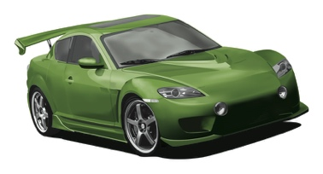_________________ ᏓᏆᎴᎳ

- 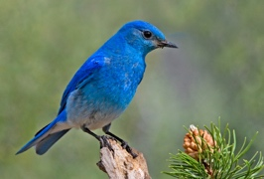 _________________ ᏥᏍᏆ

-  _________________ ᎠᏒᏍᏗ

- 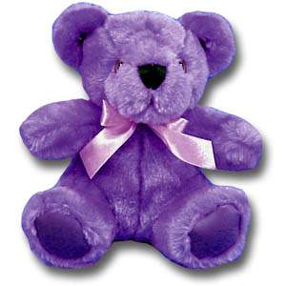 _________________ ᏲᎾ ᎢᏳᏍᏗ ᏗᏁᏟᏙᏗ

-  _________________ ᎤᎶᎩᎳ

- 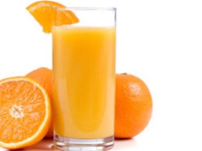 _________________ ᎠᏗᏔᏍᏗ

