**Feelings**

You have a picture indicating an emotion. When your partner asks “how are you feeling,” respond with the emotion word that matches the picture.

Ex. If my picture is: ☺ YOUR

the conversation goes: PICTURE 🡺

A: ᎨᏙᏊ ᏣᏓᎾᏘ?

B: ᎦᎵᎡᎵᎦ! ᏂᎯᎾ? ᎨᏙᏊ ᏣᏓᎾᏘ?

**Feelings**

You have a picture indicating an emotion. When your partner asks “how are you feeling,” respond with the emotion word that matches the picture.

Ex. If my picture is: ☺ YOUR

the conversation goes: PICTURE 🡺

A: ᎨᏙᏊ ᏣᏓᎾᏘ?

B: ᎦᎵᎡᎵᎦ! ᏂᎯᎾ? ᎨᏙᏊ ᏣᏓᎾᏘ?

**Feelings**

You have a picture indicating an emotion. When your partner asks “how are you feeling,” respond with the emotion word that matches the picture.



Ex. If my picture is: ☺ YOUR

the conversation goes: PICTURE 🡺

A: ᎨᏙᏊ ᏣᏓᎾᏘ?

B: ᎦᎵᎡᎵᎦ! ᏂᎯᎾ? ᎨᏙᏊ ᏣᏓᎾᏘ?

**Feelings**

You have a picture indicating an emotion. When your partner asks “how are you feeling,” respond with the emotion word that matches the picture.

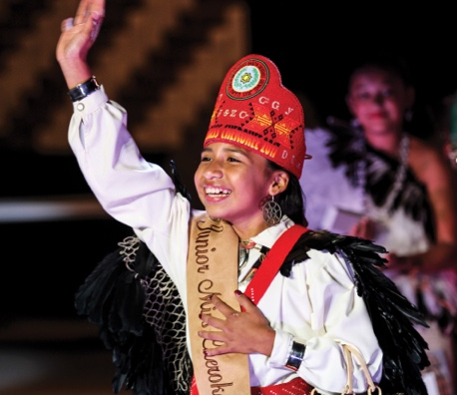

Ex. If my picture is: ☺ YOUR

the conversation goes: PICTURE 🡺

A: ᎨᏙᏊ ᏣᏓᎾᏘ?

B: ᎦᎵᎡᎵᎦ! ᏂᎯᎾ? ᎨᏙᏊ ᏣᏓᎾᏘ?

**Feelings**

You have a picture indicating an emotion. When your partner asks “how are you feeling,” respond with the emotion word that matches the picture.



Ex. If my picture is: ☺ YOUR

the conversation goes: PICTURE 🡺

A: ᎨᏙᏊ ᏣᏓᎾᏘ?

B: ᎦᎵᎡᎵᎦ! ᏂᎯᎾ? ᎨᏙᏊ ᏣᏓᎾᏘ?

**Feelings**

You have a picture indicating an emotion. When your partner asks “how are you feeling,” respond with the emotion word that matches the picture.



Ex. If my picture is: ☺ YOUR

the conversation goes: PICTURE 🡺

A: ᎨᏙᏊ ᏣᏓᎾᏘ?

B: ᎦᎵᎡᎵᎦ! ᏂᎯᎾ? ᎨᏙᏊ ᏣᏓᎾᏘ?

**Feelings**

You have a picture indicating an emotion. When your partner asks “how are you feeling,” respond with the emotion word that matches the picture.

Ex. If my picture is: ☺ YOUR

the conversation goes: PICTURE 🡺

A: ᎨᏙᏊ ᏣᏓᎾᏘ?

B: ᎦᎵᎡᎵᎦ! ᏂᎯᎾ? ᎨᏙᏊ ᏣᏓᎾᏘ?

**Feelings**

You have a picture indicating an emotion. When your partner asks “how are you feeling,” respond with the emotion word that matches the picture.



Ex. If my picture is: ☺ YOUR

the conversation goes: PICTURE 🡺

A: ᎨᏙᏊ ᏣᏓᎾᏘ?

B: ᎦᎵᎡᎵᎦ! ᏂᎯᎾ? ᎨᏙᏊ ᏣᏓᎾᏘ?

**Feelings**

You have a picture indicating an emotion. When your partner asks “how are you feeling,” respond with the emotion word that matches the picture.



Ex. If my picture is: ☺ YOUR

the conversation goes: PICTURE 🡺

A: ᎨᏙᏊ ᏣᏓᎾᏘ?

B: ᎦᎵᎡᎵᎦ! ᏂᎯᎾ? ᎨᏙᏊ ᏣᏓᎾᏘ?