Feelings
You have a picture indicating an emotion. When your partner asks “how are you feeling,” respond with the emotion word that matches the picture.

Ex. If my picture is: YOUR
the conversation goes: PICTURE

A: ᎨᏙᏊ ᏣᏓᎾᏘ?
B: ᎦᎵᎡᎵᎦ! ᏂᎯᎾ? ᎨᏙᏊ ᏣᏓᎾᏘ?

Feelings

You have a picture indicating an emotion. When your partner asks “how are you feeling,” respond with the emotion word that matches the picture.

Ex. If my picture is: YOUR
the conversation goes: PICTURE

A: ᎨᏙᏊ ᏣᏓᎾᏘ?
B: ᎦᎵᎡᎵᎦ! ᏂᎯᎾ? ᎨᏙᏊ ᏣᏓᎾᏘ?

Feelings
You have a picture indicating an emotion. When your partner asks “how are you feeling,” respond with the emotion word that matches the picture.

Ex. If my picture is: YOUR
the conversation goes: PICTURE

A: ᎨᏙᏊ ᏣᏓᎾᏘ?
B: ᎦᎵᎡᎵᎦ! ᏂᎯᎾ? ᎨᏙᏊ ᏣᏓᎾᏘ?

Feelings
You have a picture indicating an emotion. When your partner asks “how are you feeling,” respond with the emotion word that matches the picture.
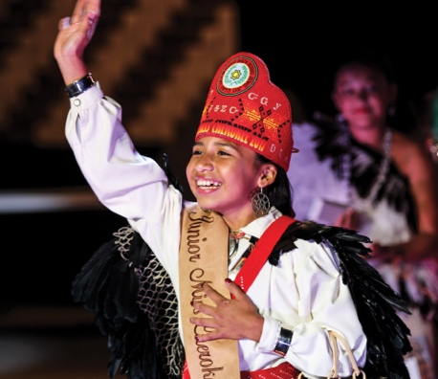
Ex. If my picture is: YOUR
the conversation goes: PICTURE

A: ᎨᏙᏊ ᏣᏓᎾᏘ?
B: ᎦᎵᎡᎵᎦ! ᏂᎯᎾ? ᎨᏙᏊ ᏣᏓᎾᏘ?

Feelings
You have a picture indicating an emotion. When your partner asks “how are you feeling,” respond with the emotion word that matches the picture.

Ex. If my picture is: YOUR
the conversation goes: PICTURE

A: ᎨᏙᏊ ᏣᏓᎾᏘ?
B: ᎦᎵᎡᎵᎦ! ᏂᎯᎾ? ᎨᏙᏊ ᏣᏓᎾᏘ?

Feelings
You have a picture indicating an emotion. When your partner asks “how are you feeling,” respond with the emotion word that matches the picture.

Ex. If my picture is: YOUR
the conversation goes: PICTURE

A: ᎨᏙᏊ ᏣᏓᎾᏘ?
B: ᎦᎵᎡᎵᎦ! ᏂᎯᎾ? ᎨᏙᏊ ᏣᏓᎾᏘ?

Feelings

You have a picture indicating an emotion. When your partner asks “how are you feeling,” respond with the emotion word that matches the picture.

Ex. If my picture is: YOUR
the conversation goes: PICTURE

A: ᎨᏙᏊ ᏣᏓᎾᏘ?
B: ᎦᎵᎡᎵᎦ! ᏂᎯᎾ? ᎨᏙᏊ ᏣᏓᎾᏘ?

Feelings
You have a picture indicating an emotion. When your partner asks “how are you feeling,” respond with the emotion word that matches the picture.
Ex. If my picture is: YOUR
the conversation goes: PICTURE

A: ᎨᏙᏊ ᏣᏓᎾᏘ?
B: ᎦᎵᎡᎵᎦ! ᏂᎯᎾ? ᎨᏙᏊ ᏣᏓᎾᏘ?

Feelings
You have a picture indicating an emotion. When your partner asks “how are you feeling,” respond with the emotion word that matches the picture.
Ex. If my picture is: YOUR
the conversation goes: PICTURE

A: ᎨᏙᏊ ᏣᏓᎾᏘ?
B: ᎦᎵᎡᎵᎦ! ᏂᎯᎾ? ᎨᏙᏊ ᏣᏓᎾᏘ?

