**ᎨᏙ ᎢᏳᏍᏗ ᏧᏂᎸᏉᏗ*?** *they like

 

ᎯᎠ ᏥᏍᏆ. ᏗᎪᏪᎵ ᏧᎸᏉᏗ! ᎯᎠ ᏦᎾ. ᎣᏍᏓ ᏗᎿᏬ ᏧᎸᏉᏗ!

ᏍᏈᏍᏓ ᏓᎪᎵᏰᏍᎪᎢ. ᎤᏬᏚ ᎤᏁᎦ ᎤᎿᏬ .ᎪᎯ ᎢᎦ.

1. ᎨᏙ ᎢᏳᏍᏗ ᏧᎸᏉᏗ ᏥᏍᏆ? ____________________________
2. ᎨᏙ ᎢᏳᏍᏗ ᏧᎸᏉᏗ ᏦᎾ? _______________________________

ᎯᎠ ᎠᏂᏴᏫ ᏍᏈᏍᏓ ᏄᎾᏓᎴᎢ ᏧᏂᎸᏉᏗ! ᏗᏒᏍᏙᏗ °ᏙᏪᎳᎦ*! *write it!

ᎥᏍᎩ ᎢᏳᏍᏗ: “ᏥᏍᏆ - ᏗᎪᏪᎵ” 🡺 “ᏗᎪᏪᎵ ᏧᎸᏉᏗ ᏥᏍᏆ.”

“ᏦᎾ - ᎣᏍᏓ ᏗᎿᏬ” 🡺 “ᎣᏍᏓ ᏗᎿᏬ ᏧᎸᏉᏗ ᏦᎾ.”

1. ᏤᎻ - ᏔᎷᏣ ᎠᎳᏍᎦᎳᏗ 🡺 ____________________________________________________________
2. ᏫᎵ - ᏣᎳᎩ ᎦᏬᏂᎯᏍᏗ 🡺 ______________________________________________________________
3. ᎺᎵ - ᏣᏔᎦ 🡺 ____________________________________________________________________________
4. ᎠᎿᏪᎩ - ᎤᏕᎶᏆᏍᏗ* 🡺 ____________________________________________________________ *‘for her to learn’
5. ᎠᏲᎧ - ᏒᎦᏔ 🡺 _________________________________________________________________________
6. ᎹᏎ - ᎧᏫ ᎤᏗᏔᏍᏗ* 🡺 _____________________________________________________________ *for her to drink

**ᎤᏛᏁᏘ* ᎤᎸᏉᏗ!** *for him/her to do it

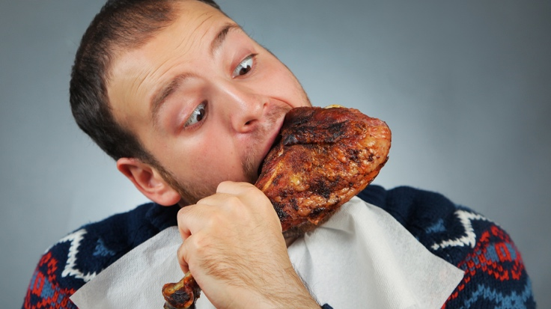 

**ᏣᏔᎦ1 ᎤᎳᏍᏓᏴᏗ ᎤᎸᏉᏗ ᎯᎠ ᎠᏍᎦᏯ2!** ᎤᏬᎩᏟ3 ᎤᏗᏔᏍᏗ ᎤᎸᏉᏗ ᎯᎠ ᎠᏍᎦᏯ

1 chicken 2. man 3. beer

°ᏙᏪᎳᎦ!

ᎨᏙ ᎢᏳᏍᏗ ᎤᎾᏛᏁᏘ ᏧᏂᎸᏉᏗ ᎯᎠ ᎠᏂᏴᏫ?

ᎯᎠ ᎢᏳᏍᏗ: “Bobby - ᏣᏔᎦ ᎤᎵᏍᏓᏴᏗ”🡺 “ᏣᏔᎦ ᎤᎵᏍᏓᏴᏗ ᎤᎸᏉᏗ Bobby.”

1. ᏛᎩ (Doug) - ᏗᎪᏪᎵ ᎤᎪᎵᏰᏗ 🡺_______________________________________________________________
2. ᏎᎾ - ᏍᏓᏯ ᏚᎸᏫᏍᏓᏁᏗ 🡺 _____________________________________________________________
3. ᎤᎾᏚᏘ - rugby ᎤᏁᏝᏙᏗ 🡺 _____________________________________________________________
4. ᏚᏯ - ᎦᏬᏂᎯᏍᏗ ᎤᏕᎶᏆᏍᏗ 🡺 _____________________________________________________________
5. ᎧᏬᏄ - ᎤᏓᏬᏍᏗ 🡺 _____________________________________________________________

ᎢᏳᎾᏛᏁᏗ: “Infinitives”

Constructions like “ᏣᏔᎦ ᎤᎵᏍᏓᏴᏗ ᎤᎸᏉᏗ ᏣᏂ” include an *infinitive*. Infinitives can be used when you want to make a verb the **direct object** of another verb. Ordinarily, the **direct object** is a noun – the thing that receives the action of the verb.

Ex.

I want **an apple**

**Subject Verb direct object** (“an apple” is the thing that gets “wanted.”)

You can put a verb in this position instead. In English, we do this using the word “to.”

I want to eat

**Subject Verb direct object** (here, “to eat” is what is “wanted.”)

In Cherokee, the infinitive (also called the “deverbal noun stem”) is the equivalent of the English “to.” Because it still carries a prefix though, it can be translated as “for (me/you/him, etc.) to do it”

ᎤᎵᏍᏓᏴᏗ ᎤᏚᎵᎭ ᏣᏂ

“for him to eat” “he wants it” John

ᏚᎸᏫᏍᏓᏁᏗ ᎤᎸᏉᏗ ᏫᎵ

“for him to work” “he likes it” Will

**Exercise!**

Given the *infinitive* for each verb, write a sentence using either “likes to” (-ᎸᏉᏗ) or “wants to” (-ᎠᏚᎵᎭ). Use the prefix appropriate to the person indicated (All verbs in the infinitive take SET B prefixes).

Ex. -ᏍᏕᎳᏗ “help” – 1st person singular - ᎠᏆᏍᏕᎳᏗ ᎠᏆᏚᎵᎭ!

(NOTE: Your prefixes on both verbs should match! It changes the meaning if they don’t.)

1. -ᎠᏗᏔᏍᏗ “drink” – 1st person dual exclusive - ___________________________________________
2. -ᎸᏫᏍᏓᏁᏗ “work” – 3rd person plural - ______________________________________________________
3. -ᏃᎩᏍᏗ “sing” – 2nd person singular - ________________________________________________________
4. -ᎪᎵᏰᏗ “read” – 2nd person dual - _____________________________________________________________
5. -ᎣᏪᎶᏙᏗ “write” – 1st person dual inclusive - _______________________________________________
6. -ᎠᎵᏍᎩᏍᏗ “dance” – 1st person plural inclusive - __________________________________________
7. -ᎠᏕᎳᎰᎯᏍᏗ “find out” – 3rd person plural - _________________________________________________
8. -ᏬᏂᏍᏗ “speak” – 1st person singular - _______________________________________________________
9. -ᎠᏕᎶᏆᏍᏗ “learn” – 2nd person plural - ______________________________________________________
10. -ᎠᏓᎾᏖᏗ “think” – 1st person singular - _______________________________________________________