Info Gap: Feelings A
Gedogwu unadanti hi’a aniyvwi? Hitadvhvga kilo “B” gohwelanv tsuquaniyosdi tsutseli’i.
Ex. A: “Gedogwu udanti Greg?”
B: “oh… gatlvsga gohi iga¹.” ^{1. gohi iga- today}
Meli | Dikanowadido | Tohisgi | Saloli
 | ?? | 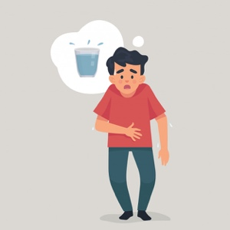 | ??
Tsunulahvsga | Alani | Udatlohida | Inoli
?? | 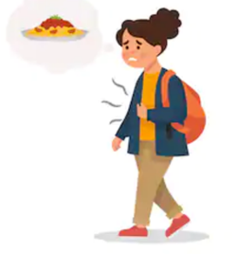 | ?? | 
Dikane’isdi kanesa:
gatlvsga | uyo’i udanti | osda udanti
aliheliga | uyosiha | duyawega
 | utadegi’a

Info Gap: Feelings B
Gedogwu unadanti hi’a aniyvwi? Hitadvhvga kilo “B” gohwelanv tsuquaniyosdi tsutseli’i.
Ex. A: “Gedogwu udanti Greg?”
B: “oh… gatlvsga gohi iga¹.” ^{1. gohi iga- today}
Meli | Dikanowadido | Tohisgi | Saloli
?? |  | ?? | 
Tsunulahvsga | Alani | Udatlohida | Inoli
 | ?? |  | ??
Dikane’isdi kanesa:
gatlvsga | uyo’i udanti | osda udanti
aliheliga | uyosiha | duyawega
 | utadegi’a

