A

You are entertaining several guests at a party, but you don’t know what they all like to eat and drink! Ask a partner to fill in the gaps! (Switch partners for each question)

ᏚᏙᎥᎢ: ᎠᎩᏍᏗ : ᎠᏗᏔᏍᏗ:

Ex. 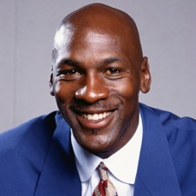 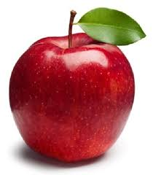 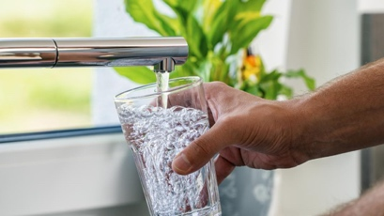

Michael

“ᎨᏙ ᎢᏳᏍᏗ ᎤᎸᏉᏗ ᎤᎩᏍᏗ Michael?” “ᎨᏙ ᎢᏳᏍᏗ ᎤᏗᏔᏍᏗ ᎤᎸᏉᏗ Michael?”

“ᏒᎦᏔ ᎤᎩᏍᏗ ᎤᎸᏉᏗ.” “ᎠᎹ ᎤᏗᏔᏍᏗ ᎤᎸᏉᏗ.”

|  |  |  |
| --- | --- | --- |
|  | ᎠᎩᏍᏗ: | ᎠᏗᏔᏍᏗ |
| ᎺᎵ | ? | Image result for beer |
| ᏣᏂ | Image result for sandwich | ? |
| ᎠᎿᏪᎩ | ? | Image result for milk |
| ᎠᏴᏓᏆᎶᏍᎩ | Image result for blackberry | ? |
| ᏆᎾ | Image result for potato | ? |
| ᏇᏗ | ? | Image result for orange juice |

B

You are entertaining several guests at a party, but you don’t know what they all like to eat and drink! Ask a partner to fill in the gaps! (Switch partners for each question)

ᏚᏙᎥᎢ: ᎠᎩᏍᏗ : ᎠᏗᏔᏍᏗ:

Ex.   

Michael

“ᎨᏙ ᎢᏳᏍᏗ ᎤᎸᏉᏗ ᎤᎩᏍᏗ Michael?” “ᎨᏙ ᎢᏳᏍᏗ ᎤᏗᏔᏍᏗ ᎤᎸᏉᏗ Michael?”

“ᏒᎦᏔ ᎤᎩᏍᏗ ᎤᎸᏉᏗ.” “ᎠᎹ ᎤᏗᏔᏍᏗ ᎤᎸᏉᏗ.”

|  |  |  |
| --- | --- | --- |
|  | ᎠᎩᏍᏗ: | ᎠᏗᏔᏍᏗ |
| ᎺᎵ | Image result for cowImage result for beef | ? |
| ᏣᏂ | ? | Image result for coffee |
| ᎠᎿᏪᎩ | Image result for cookies | ? |
| ᎠᏴᏓᏆᎶᏍᎩ | ? | Image result for whiskyImage result for whisky |
| ᏆᎾ | ? | Image result for cola |
| ᏇᏗ | Image result for banana | ? |