A

You are entertaining several guests at a party, but you don’t know what they all like to eat and drink! Ask a partner to fill in the gaps! (Switch partners for each question)

ᏚᏙᎥᎢ: ᎠᎩᏍᏗ : ᎠᏗᏔᏍᏗ:
Ex.   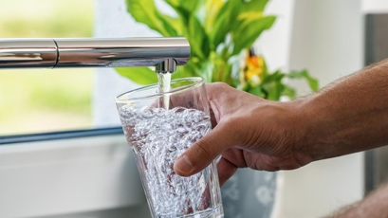
Michael

“ᎨᏙ ᎢᏳᏍᏗ ᎤᎸᏉᏗ ᎤᎩᏍᏗ Michael?” “ᎨᏙ ᎢᏳᏍᏗ ᎤᏗᏔᏍᏗ ᎤᎸᏉᏗ Michael?”
“ᏒᎦᏔ ᎤᎩᏍᏗ ᎤᎸᏉᏗ.” “ᎠᎹ ᎤᏗᏔᏍᏗ ᎤᎸᏉᏗ.”

 | ᎠᎩᏍᏗ: | ᎠᏗᏔᏍᏗ
ᎺᎵ | ? | 
ᏣᏂ | 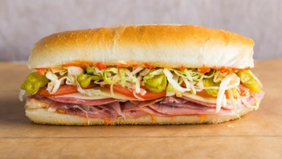 | ?
ᎠᎿᏪᎩ | ? | 
ᎠᏴᏓᏆᎶᏍᎩ |  | ?
ᏆᎾ |  | ?
ᏇᏗ | ? | 

B
You are entertaining several guests at a party, but you don’t know what they all like to eat and drink! Ask a partner to fill in the gaps! (Switch partners for each question)

ᏚᏙᎥᎢ: ᎠᎩᏍᏗ : ᎠᏗᏔᏍᏗ:
Ex.
Michael
“ᎨᏙ ᎢᏳᏍᏗ ᎤᎸᏉᏗ ᎤᎩᏍᏗ Michael?” “ᎨᏙ ᎢᏳᏍᏗ ᎤᏗᏔᏍᏗ ᎤᎸᏉᏗ Michael?”
“ᏒᎦᏔ ᎤᎩᏍᏗ ᎤᎸᏉᏗ.” “ᎠᎹ ᎤᏗᏔᏍᏗ ᎤᎸᏉᏗ.”

 | ᎠᎩᏍᏗ: | ᎠᏗᏔᏍᏗ
ᎺᎵ |  | ?
ᏣᏂ | ? | 
ᎠᎿᏪᎩ |  | ?
ᎠᏴᏓᏆᎶᏍᎩ | ? | 
ᏆᎾ | ? | 
ᏇᏗ |  | ?

