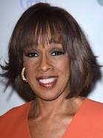 | 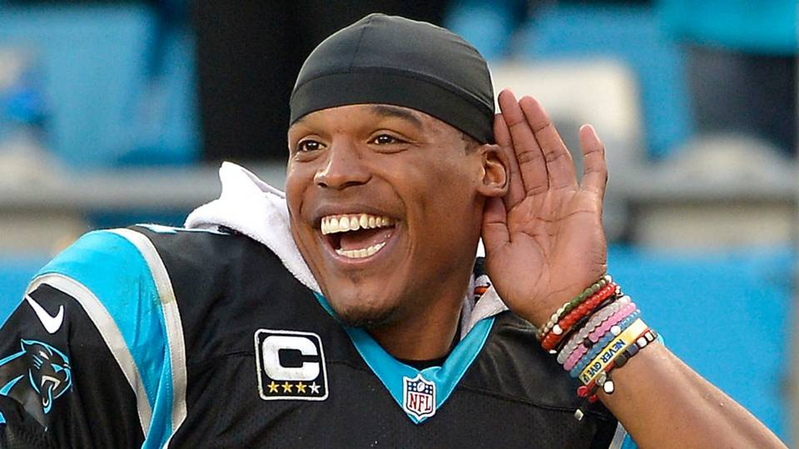 | 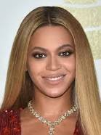
ᏚᏙᎠ: Gayle King | ᏚᏙᎠ: Cam Newton | ᏚᏙᎠ: Beyoncé Knowles-Carter
ᎤᏕᏅ: 1954, Chevy Chase, Maryland | ᎤᏕᏅ: 1989, Atlanta, GA | ᎤᏕᏅ: 1981, Houston, TX
64 ᏧᏕᏘᏴᏓ | 29 ᏧᏕᏘᏴᏓ | 37 ᏧᏕᏘᏴᏓ
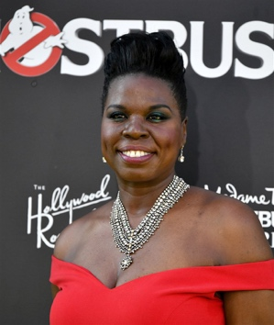 | 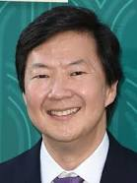 | 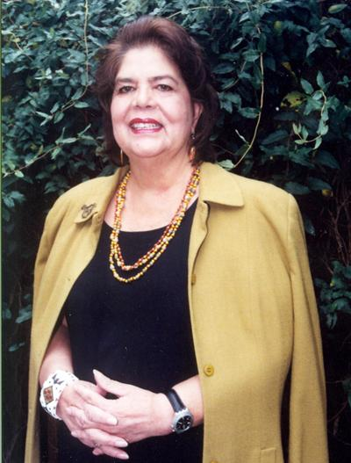
ᏚᏙᎠ: Leslie Jones | ᏚᏙᎠ: Ken Jeong | ᏚᏙᎠ: Wilma Mankiller
ᎤᏕᏅ: 1967, Memphis, TN | ᎤᏕᏅ: 1969, Detroit, MI | ᎤᏕᏅ: 1945, Tahlequah, OK
51 ᏧᏕᏘᏴᏓ | 49 ᏧᏕᏘᏴᏓ | 64 ᏧᏕᏘᏴᏓ ᏥᎨᏒ, ᏧᏰᏲᎱᏎᎴ

