A

You know only half of the guests at the party! Find out what people’s names are!

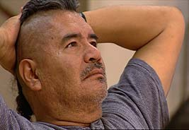 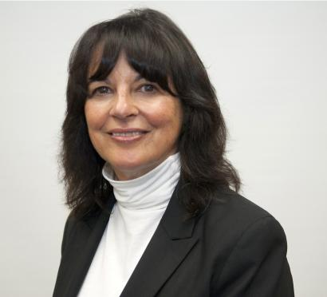 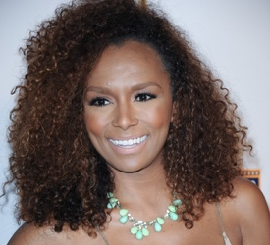

Bob ______________ Meg

 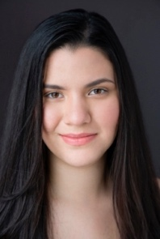 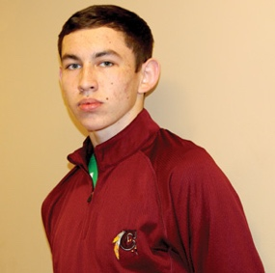

Yansa __________ ______________

B

You know only half of the guests at the party! Find out what people’s names are!

  

__________________ Carol ______________

  

__________ Saloli Doyanida