ᎨᏙ ᎢᏳᏍᏗ ᏂᎦᎵᏍᏗᏍᎪᎢ...?

Match the pictures with the appropriate season:

a. 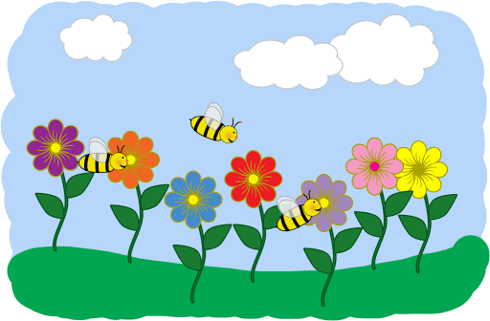 b.  c.  d. e.f. g.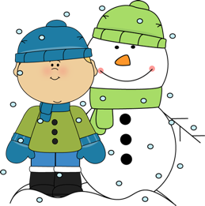h.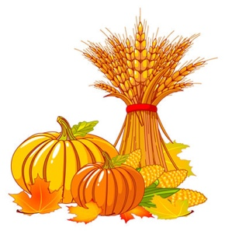i. 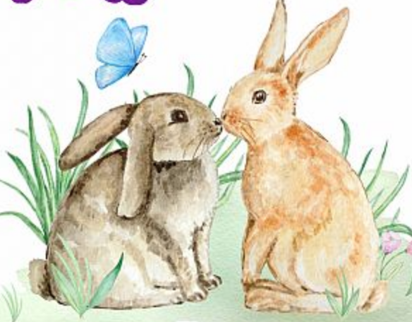

ᎪᎨᏱ: ________________________________________________________________________

ᎪᎩ: ________________________________________________________________________

ᎤᎵᎪᎲᏍᏗ:___________________________________________________________________

ᎪᎳ: ________________________________________________________________________

ᎨᏙ ᎢᏳᏍᏗ ᏂᎦᎵᏍᏗᏍᎪᎢ...?

Match the pictures with the appropriate season:

a.  b.  c.  d. e.f. g.h.i.

ᎪᎨᏱ: ________________________________________________________________________

ᎪᎩ: ________________________________________________________________________

ᎤᎵᎪᎲᏍᏗ:___________________________________________________________________

ᎪᎳ: ________________________________________________________________________