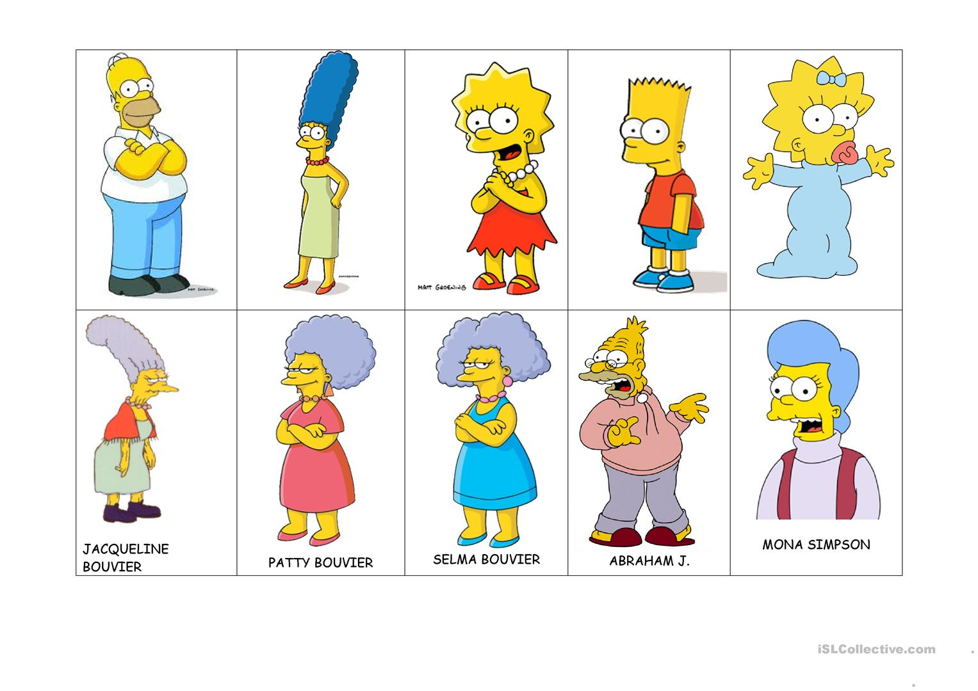

|  |  |  |  |  |
| --- | --- | --- | --- | --- |
| udoda | utsi | Lisa | udohi | ulvhi |
| ulisi | taline unitsi | taline unitsi | ududu | unisi |