Info Gap! A
You know how the weather’s going to look this week...probably... compare notes with your partner and see what the two of you think will happen.
Ex. A: “ᎤᎾᏙᏓᏉᏅ ᎨᏎᏍᏗ ᎨᏙ ᎢᏳᏍᏗ ᏂᎦᎵᏍᏗᏍᎨᏍᏗ ᏙᏱ?”
B: “ᎫᏘᏍᎨᏍᏗ ᎡᎵᏍᏗ!” ᎡᎵᏍᏗ (maybe/possibly)
ᎤᎾᏙᏓᏆᏍᎬ | ᎤᎾᏙᏓᏉᏅ | ᏔᎵᏁ ᎢᎦ | ᏦᎢᏁ ᎢᎦ | ᏅᎩᏁ ᎢᎦ | ᏧᏂᎩᎶᏍᏗ | ᎤᎾᏙᏓᏈᏕᎾ
???? | ???? | 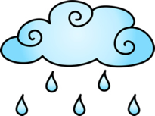  ¹ | ²  ???? | ³  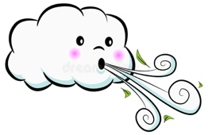 | ⁴  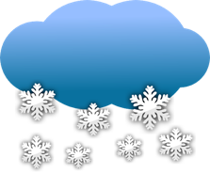 | ⁵

Info Gap! B
You know how the weather’s going to look this week...probably... compare notes with your partner and see what the two of you think will happen.
Ex. A: “ᎤᎾᏙᏓᏉᏅ ᎨᏎᏍᏗ ᎨᏙ ᎢᏳᏍᏗ ᏂᎦᎵᏍᏗᏍᎨᏍᏗ ᏙᏱ?”
B: “ᎫᏘᏍᎨᏍᏗ ᎡᎵᏍᏗ!” ᎡᎵᏍᏗ (maybe/possibly)
ᎤᎾᏙᏓᏆᏍᎬ | ᎤᎾᏙᏓᏉᏅ | ᏔᎵᏁ ᎢᎦ | ᏦᎢᏁ ᎢᎦ | ᏅᎩᏁ ᎢᎦ | ᏧᏂᎩᎶᏍᏗ | ᎤᎾᏙᏓᏈᏕᎾ
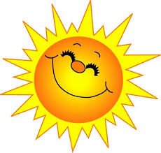 | 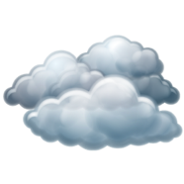 | ¹  ???? | ²  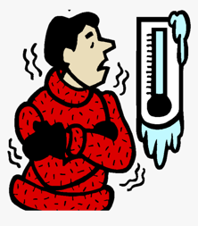 | ³  ???? | ⁴  ???? | ⁵

